*Profiles appear in the order in which presenter names appear in the agenda.
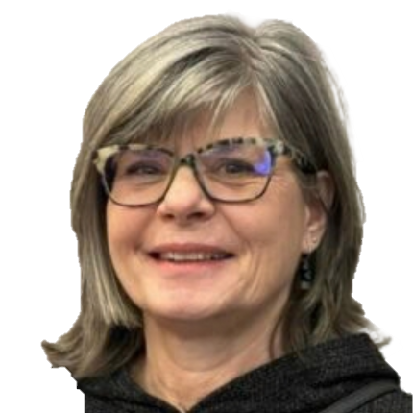
Anne Kresta is the Executive Director of Level It Up, a Winnipeg-based nonprofit that supports post-secondary students and graduates with autism in transitioning to meaningful employment in STEM and the arts. An advocate in the disability and autism community for 30 years, she also co-founded Neurowrx, a global alliance of organizations and businesses advancing autism and neurodiverse employment through collaboration and knowledge sharing. Neurowrx organizations each have their own regional characteristics but come together to share practices and knowledge to learn and grow from each other.

Peter Field is an Accessibility and Inclusion consultant living in British Columbia. In 2019 he retired from a 28-year career with Canada’s federal Public Service. Since then, he has worked on projects with the Province of British Columbia, the Rick Hansen Foundation, the CNIB Research Team, and the National Network for Equitable Library Service. In his not so much spare time, he leads the Triple Vision podcast team in developing monthly podcasts on issues of blindness in Canada.
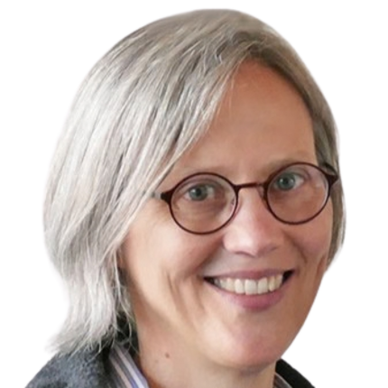
Gillian Hamilton holds appointments at the University of Toronto as the Vice-Dean, Academic Planning, and Associate Professor in the Department of Economics at the Faculty of Arts and Science. She is an affiliated faculty member with the Centre for the Study of the United States at the Munk School of Global Affairs & Public Policy. Hamilton served as associate chair, undergraduate of the Department of Economics from 2015–2020 and chair of the Faculty of Arts & Science Council. She has also served on the Canadian Economics Association’s Executive Council and the Board of Trustees of the Cliometric Society. In 2020, Professor Hamilton received the Faculty of Arts & Science’s Outstanding Teaching Award, a distinction that recognizes teaching excellence in the classroom as well in course design and curriculum development.
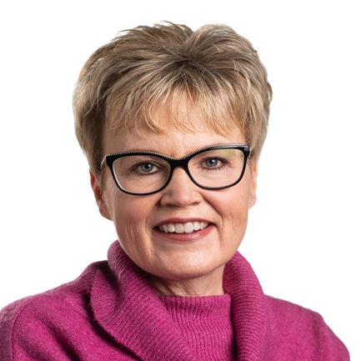
Krista Carr is a long-time advocate in the inclusion movement, with over 25 years of experience in the non-profit sector as a champion of inclusion. She is IDEA’s Advisory Committee Chair and the Executive Vice President (CEO) of Inclusion Canada, one of Canada’s 10 largest charitable organizations. She is responsible for leading the Inclusion Canada National organization, the Inclusion Canada Foundation, Inclusive Education Canada (IEC). Carr is a graduate of the University of New Brunswick (UNB) where she earned a bachelor’s in business administration (BBA) and several diplomas in Human Resources and Management from UNB’s College of Extended Learning. She is fluently bilingual and works on behalf of CACL’s federation in both French and English. She currently resides in New Brunswick with her husband and two daughters.

Rafael Gomez is a professor of employment relations and, since 2015, Director of the Centre for Industrial Relations and Human Resources at the University of Toronto. He is co-lead IDEA’s Training and Skills Development Activity Area. Gomez’s current research examines the role of unions and other labour market institutions in providing the employee voice, and what this means for workers and broader democratic engagement. In 2005, Gomez was awarded the U.S Labor and Employment Relations Association’s John T. Dunlop Outstanding Scholar Award for exceptional contributions to international and comparative labour and employment research. In 2013-14, his book The Little Black Book for Managers was a U.K. business book bestseller. His second book, Small Business and the City, was published in 2015. Gomez earned a PhD and an MA in industrial relations, as well as an MA in economics, from the University of Toronto. He got his BA in economics and political science from Glendon College at York University.

Emile Tompa is the is Executive Director of IDEA, co-lead of IDEA’s Hub on Workplace Systems and Partnerships, and a Senior Scientist at the Institute for Work & Health (IWH). A labour and heath economist, Tompa holds appointments as Associate Professor in the Department of Economics at McMaster University and as Assistant Professor at the Dalla Lana School of Public Health at the University of Toronto. Tompa’s current research focuses on analyzing the nature and impact of disability, health and safety systems, conducting economic evaluations of workplace interventions for primary and secondary prevention, and understanding the impact of labour market experiences on health and well-being. Tompa has a PhD in labour and health economics from McMaster University, an MBA from the University of British Columbia, and an MA in economics from the University of Toronto.

Tammy Morris is EY’s Accessibility & Neuroinclusion Leader, with more than two decades of experience advancing inclusive, high-performing workplaces across Canada and the United States. Tammy has designed and scaled inclusive employee experiences across the talent lifecycle, from recruitment and onboarding through development, career trajectory and retention. She advises organizations on embedding accessibility, inclusive AI and universal design into policy, digital and human-centred design, workplace practices and enterprise transformation, while strengthening compliance with global accessibility requirements. Above all, Tammy champions a strengths-first approach that recognizes cognitive diversity as a business advantage. She helps organizations future-proof their workforces by attracting and empowering innovative thinkers and complex problem-solvers with in-demand skills in cybersecurity, big data and emerging technology. By connecting evidence-based methods and business strategy, Tammy enables sustainable cultures of belonging and delivers measurable results across industries in an evolving global economy.

Andrew Dixon is an interdisciplinary PhD candidate at Memorial University in St. John's, Newfoundland, specializing in neurodiversity and developing more inclusive workplaces. He is a research associate with IDEA Hub on Workplace Systems and Partnerships. Dixon holds a master’s in philosophy (Humanities) from Memorial University and a BA in history from the Royal Military College. Dixon is skilled in qualitative methods and evidence synthesis. His PhD work primarily focuses on ethnographic approaches to social justice and disability rights. He is a recipient of a MITACS fellowship to study the Disability Tax Credit system and a Florence Fox Memorial Scholarship to study the social impact of Parkinson’s disease. Dixon has lived experience with neurodiversity and invisible disability. Outside of IDEA and academia, Dixon is involved in several advocacy initiatives with marginalized disability communities that focus on better living conditions. Dixon's commitment to community service is evident through his active volunteerism with Scouts Canada and the Autism Society of Newfoundland.

Dilshan Fernando is a Research Associate at IDEA 4DY and an Accessibility & Equity Officer at University of Guelph, leading institutional accessibility and equity at its Office of Diversity and Human Rights. In his work with IDEA, He focuses on accessibility planning and reporting and the implementation of a survey of employer best practices for accessibility and inclusion of persons with disabilities. Fernando is a PhD candidate in sociology and international development at the University of Guelph. His doctoral project is an in-depth case study of replicable disability inclusion best practices in a large private-sector organization in India. He is also a Research Fellow at LIRNEasia, a digital policy think tank based in Colombo, Sri Lanka.

Mahadeo Sukhai is the world’s first congenitally blind geneticist. He is the COO of IDEA STEM and holds adjunct faculty appointments at University of Ontario Institute of Technology, Queens University, and OCAD University. Sukhai chairs the Employment Technical Committee for Accessibility Standards Canada. He is the external co-chair of the Canadian Institutes of Health Research (CIHR) Expert Advisory Committee on Accessibility and Systemic Ableism. He also serves on the Boards for Health Data Research Network Canada and the Institute of Neurodiversity Canada, and is a member of the steering committee for Disability and Work in Canada. Sukhai has a PhD in medical biophysics and a PhD in cancer genetics, both from the University of Toronto. Sukhai co-leads IDEA’s Hub 4, Inclusive Environmental Design.

Jeff Willbond is the Chief Accessibility Officer at March of Dimes Canada. He brings more than 30 years of experience advancing accessibility, human rights, and organizational change across the public, private, and non-profit sectors. As CAO, Willbond leads the development and implementation of a Multi-Year Accessibility and Disability Inclusion Plan at March of Dimes, ensuring accessibility and inclusion are deeply integrated into our service delivery, community engagement, employment practices, and culture. Jeff’s career began in Ottawa supporting people with disabilities through employment counselling and community services. He has since held senior leadership roles with the Canadian Human Rights Commission, the Government of Canada, and Canada Post, where he developed and implemented accessibility strategies aimed at increasing representation and removing barriers for people with disabilities.

Sherene Mitchell is a Project Manager at Excellence in Manufacturing Consortium (EMC), where she leads HerJourney, a federally funded initiative supporting women in manufacturing and skilled trades. With a career rooted in sustainability, Sherene has led volunteer and community initiatives in collaboration with organizations focused on supporting the advancement of women and children, ensuring equity and inclusion are at the core of decision-making.
Her work at EMC has allowed her to move social impact from one pillar of sustainability to a dedicated focus, applying an equity and inclusion lens to the manufacturing sector and working with employers, industry professionals, and women in skilled trades to help create more inclusive workplaces. Through HerJourney, she brings together her experience in social impact, inclusion, and community engagement to support meaningful change across the manufacturing sector.

Mohamed Elmi is the Executive Director of the Diversity Institute. The Diversity Institute conducts and coordinates multi-disciplinary, multi-stakeholder research to address the needs of diverse Canadians, the changing nature of skills and competencies, and the policies, processes and tools that advance economic inclusion and success. Mohamed holds a PhD in Information Systems at University of Cape Town. Prior to this, Mohamed completed his thesis Masters of Arts in International Development Studies at Saint Mary’s University in Halifax, Nova Scotia and an Honour Bachelor of Arts in Political Science from the University of New Brunswick.

Alison Staples is the Chief People Officer and Chief Privacy Officer at March of Dimes Canada, as well as the Board Chair of the Human Resources Professionals Association. She has more than 20 years of experience creating positive, high-performing work environments in the not-for-profit sector, including in senior roles at the Canadian Breast Cancer Foundation, the Canadian Cancer Society, and Kids Help Phone.
Alison leads MODC's efforts to build a stronger, more connected workplace where employees and volunteers feel supported, empowered, and inspired. She is passionate about equity, accessibility, and human potential. Her work is centered on building strong, future-ready organizations that reflect and serve diverse communities across Canada. She’s a certified Diversity, Equity, and Inclusion professional and completed the High Potential Leadership Program at Harvard University.

Rola Helou, CPHR, Adm.A., is the Chief Executive Officer of CPHR Canada and a respected leader in human resources, inclusion, and governance. She began her career in the education sector, where she developed a lasting commitment to accessibility and equitable practice; principles that continue to guide her leadership.
Rola is known for her ability to lead organizations through growth and change, strengthen respectful workplace practices, and modernize HR systems with clarity and purpose. Her governance and leadership experience spans regional and provincial organizations, and most recently prior to joining CPHR Canada, a consulting practice recognized for its strategic insight and diagnostic rigour.
As CEO, she brings a values‑driven perspective to advancing the HR profession and fostering inclusive, ethical workplaces across Canada.
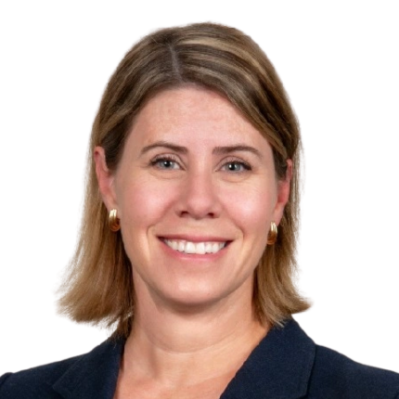
Erin Sailer is the Director of Communications and Member Services at the Civil Service Superannuation Board in Winnipeg, Manitoba. As a Chartered Professional in Human Resources (CPHR), she is passionate about engaging people, systems and technology to understand and solve problems, as well as to deliver better services. In June 2026, she was named Board Chair of CPHR, which represents over 31,000 members nationwide. She is a Chartered Member of the Chartered Institute of Personnel and Development (MCIPD), as well as a Certified Employee Benefit Specialist (CEBS). Sailer holds a Bachelor of Commerce degree, specializing in Human Resources and International Business.


Dan Samosh is an Assistant Professor, Employment Relations Studies at Queen’s University and an Adjunct Scientist at the Institute for Work & Health. He co-leads IDEA’s Hub on Transitions to Work and Career Development. Prior to his posting at Queen’s, Samosh was a Post-Doctoral Researcher at the Institute for Work & Health and at the Centre for Industrial Relations and Human Resources at the University of Toronto. Samosh’s current research looks at the work experiences of persons with disabilities, with a particular focus on the leadership emergence of persons with disabilities, disability stigma and social identity, and workplace inclusion of persons with disabilities. Samosh earned his PhD in organizational behaviour and MSc in management at the Smith School of Business at Queen’s University.

Sinead McCarthy is Vice President of Development, Programs and HR at Youth Employment Services (YES), a national agency that offers employment counselling, training and placement programs for disadvantaged and vulnerable youth in Canada. She joined YES in 1999, where she was previously Vice-President, Administration and Special Projects. McCarthy co-leads IDEA’s Hub on Transitions to Work and Career Development. Sinead has a BSocSc from University College Cork, a Certificate in Labour Relations from Sheridan College and a Certificate in Financial Management for Non-profits from the Chang School of Continuing Education at Toronto Metropolitan University. She is currently working toward a Certified Human Resources Leader (CHRL) designation.


Karen Harlos is a professor and past Inaugural Chair of the Department of Business and Administration at the University of Winnipeg. She is lead of IDEA's Equity, Diversity, Inclusion and Accessibility Activity Area. Harlos’s expertise is in organizational behaviour, organizational psychology, psychometrics and human resources. Her research focuses on workplace bullying and mistreatment, employee silence and voice in the face of mistreatment, and workplace issues in healthcare. Harlos co-authored a teaching case on workplace mistreatment that won the Outstanding Compact Case Competition Winner at the international 2022 Case Centre Awards. (Case Centre, established in the U.K. in 1973, is an international not-for-profit that promotes “the case method” as an essential part of management education in business schools.) Harlos has a PhD in organizational behaviour, an MA in organizational/industrial psychology and a BA in clinical psychology, all from the University of British Columbia.

Ashvene Sureshkumar is a PhD Candidate at the University of Toronto within the Rehabilitation Sciences Institute (RSI). She is a research associate in IDEA’s Hub on Workplace Systems and Partnerships, working under the direction of Emile Tompa and Emma Irvin. Sureshkumar is skilled in evidence synthesis, qualitative methodologies, quantitative methodologies and mixed methods. She has experience with equity, diversity, inclusion and accessibility (EDIA) research and her areas of research expertise include mixed methods, mindfulness-based interventions, health services research and people living with multiple sclerosis. Her PhD work involves developing an implementation toolkit for building online mindfulness-based interventions for people living with multiple sclerosis. Sureshkumar holds a Bachelor of Health Science (BHSc) and a Master of Science (MSc) in Health and Rehabilitation Sciences from Western University. In 2024, Ashvene was awarded the endMS Doctoral Student Award to support her doctoral research.

Shannon Killip is an IDEA postdoctoral associate, housed within McMaster University. She is the recipient of the first David C. Onley Postdoctoral Research Award in Work Disability Policy. Killip is working within IDEA's Incubator Hub on Employment Support Systems under the supervision of Rebecca Gewurtz. Killip is also a sessional instructor in Rehabilitation Sciences at McMaster University. She is interested in research on return to work and disability management, first responder health and wellbeing, and chronic pain. Killip holds a PhD in Rehabilitation Sciences from McMaster University; she defended her thesis in September 2024.

Matt Freeman is an Assistant Clinical Professor, McMaster University where he has worked in the School of Rehabilitation Science since 2007 in various roles. Freeman’s research interests include information needs during the transition to adulthood for youth with disabilities and their families, including employment. Since the pandemic, Freeman has also explored a program of research examining the development, implementation and impact of COVID-19 related infection control policies in congregate care settings in the developmental services sector in Ontario under the leadership of Dr. Briano Di Rezze.

Jennifer Harmer is a PhD candidate at the Centre for Industrial Relations & Human Resources. After obtaining an undergraduate degree in labour studies and political science at McMaster University, Harmer obtained a master’s degree in public administration at Western University. She worked in progressive positions from economist to manager before pursuing a PhD. Management experience has helped her develop skills to bridge the world of research and practical application. Jen’s research is the Canadian component of The International Union Administration. She documents Canadian unions from the perspective of their internal human resource management (HRM) practices. These practices include recruitment, selection, training, development, as well as performance management and other strategies focused on the administration of the workforce.

Or Shay is a postdoctoral researcher at the Centre for Industrial Relations and Human Resources (CIRHR) at the University of Toronto. Or received his PhD from the Industrial and Labor Relations (ILR) School at Cornell University. Or studies collective bargaining, labour relations, unions, labour law, and their impacts on working people and society. Before his graduate studies, Or was a lawyer in the field of labour and employment law.

Emmanuelle Lopez-Bastos is the National Coordinator, Human Rights, Equity and Diversity at UFCW Canada. Over the last 16 years at UFCW, she has led national and international human rights initiatives. Lopez-Bastos is a seasoned leader in the development and execution of social justice initiatives, such as programming aimed at expanding social justice education, while strengthening member and community engagement. She is the Chair of the National UFCW Canada Human Rights, Equity and Diversity Committee, as well as Chair of the National UFCW Canada Indigenous Sub-Committee. Lopez-Bastos is also a member of the Accessible Standards Canada Technical Committee on Employment for persons with disabilities. In 2020, she co-led an international survey on the workplace experiences of LGBTQ+ workers with UCLA Labor Centre and UFCW OUTreach constituency group.

Laura Peña is a proud Latina, advocate, and equity practitioner based in Tkaronto, also known by its colonial name, Toronto. She holds a Bachelor’s degree in Socio-Cultural Anthropology from York University and a Master’s degree in Equity Studies from Athabasca University. Her work with an Indigenous women’s shelter and a Latino community centre, along with her research on white supremacy culture within organizations, has deepened her commitment to equity, feminism, and decolonization. A recipient of the Glass Ceiling Award, Laura brings curiosity and a strong sense of commitment to her work. She is passionate about learning from others and helping create spaces where people feel empowered to contribute to a more just future.
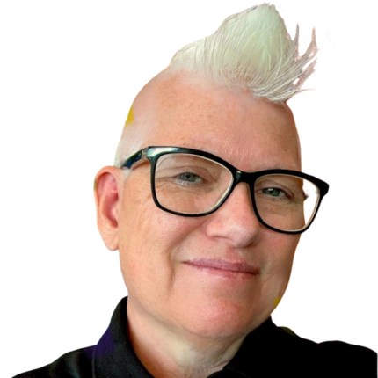
Jennifer Hope is the Director of Development and Capacity Building at the Ontario Disability Employment Network (ODEN). They work at the intersection of business, community, and workforce development to advance disability-inclusive employment. Hope is a passionate advocate for disability inclusion, with a career spanning the public, private, and non-profit sectors. With over 15 years of experience in the non-profit space and senior leadership roles in Toronto’s developmental services sector, they bring a deep expertise of capacity building and inclusive employment strategies.
A former Red Seal–certified executive chef, she blends lived experience with professional insight to drive meaningful progress in inclusion. Jenny works collaboratively with employers, service providers, and community stakeholders to expand equitable employment opportunities—grounded in the belief that employment is more than just a job; it’s a pathway to connection, purpose, and social inclusion.

Lisa Liskovoi is an inclusive designer and accessibility specialist who helps public and private sector organizations and non-profits create more inclusive experiences. With a background in design, psychology, and digital accessibility, she explores how the boundaries of designs can be pushed to serve a wider range of human diversity. Lisa is working on AI accessibility and AI literacy under IDEA's Hub on Disruptive Technologies and the Future of Work. She contributes to the development of accessibility standards and guidance, including serving on Accessibility Standards Canada's technical committee for the Accessible and Equitable Artificial Intelligence Systems Standard and participating in the W3C Authoring Tool Accessibility Guidelines (ATAG) Community Group.


Raf Khan is the Director, Manufacturing Initiatives at the Excellence in Manufacturing Consortium (EMC). With more than two decades of human resources and marketing experience, Raf is well-qualified to design and deliver manufacturing projects and programs related to workforce development, skills development, and training.
With a background in recruitment strategy, social media, and employment branding for two large national organizations, since joining EMC three years ago he has led the development and execution of many successful projects and initiatives to help members in the manufacturing industry meet some of their most pressing workforce challenges. These solutions include introducing youth to manufacturing and skilled trades, developing a green manufacturing training program, and an industry-led micro-credential training and strategy program. Khan holds a B.A. in Economics from Memorial University in Newfoundland and Labrador.

Sharon McCarry is a nationally recognized disability advocate, community leader, and founder of La Fondation Place Coco which developed and supports The Little Red Playhouse, a bilingual inclusive early learning and intervention centre supporting children with neurodevelopmental disabilities and their families. McCarry has over three decades of leadership experience spanning the private, non-profit, and advocacy sectors. She has held senior executive positions in marketing and communications while also leading numerous initiatives focused on disability inclusion, autism advocacy, and community engagement. She currently serves in advisory and leadership roles with several national organizations and research networks, including Autism Alliance of Canada and disability-focused research initiatives. Currently, she is the co-chair of the Economic Inclusion committee working on the National Autism Strategy action plan since 2024 and has recently been appointed to the National Council on Poverty appointed through the Governor in Council for the Minister of Jobs and Families for the period Nov 2026 to Sept 2028. Previously from 2020 to 2024, she served on the Disability Advisory Committee of the Canada Revenue Agency, including as Co-Chair, where she contributed to recommendations on improving federal disability-related tax measures and benefits. She holds a Bachelor of Arts from McGill University and has pursued extensive professional development in equity, diversity, inclusion, accessibility, Indigenous reconciliation, and community engagement.

Bilan Arte is an award-winning activist and organizer with over fifteen years of experience in campaigns, leadership, and movement building. She holds a master's degree in public administration from the University of Ottawa, and she is the National Representative for Human Rights at the Canadian Labour Congress. Arte is a Black, Muslim feminist who lives and works in the unceded and never-surrendered traditional territories of the Algonquin and Anishinaabe peoples. In all aspects of her work, Arte is fueled by her passion for social justice and equity.

Valerie Vanderwyk is Executive Director, Indigenous Skills, Employment, Apprenticeship, and Development (ISEAD) and a proud Mi'kmaq woman whose family originated from Nova Scotia and New Brunswick. Vanderwyk is leading ISEAD’s national expansion and advances equitable opportunities for Indigenous workers and youth through apprenticeship, occupational health and safety, and workforce development initiatives. As a certified occupational health and safety instructor, Vanderwyk partners with the province of Ontario’s designated training centre to ensure safety for workers through meaningful training, and compliance with legislation and regulations across all sectors for Indigenous workers. Vanderwyk is a Director with the Aboriginal Skilled Workers Association (ASWA), the Treasurer of the Grand Valley Education Society (GVES), a Director with Roots to Roofs, and a Director with the Canadian Apprenticeship Forum (CAF). She was nominated for a YWCA Woman of Distinction Award for creating Ontario’s first pre-apprenticeship training program in welding and plumbing for women. She also received the CSA Award of Merit for her leadership in developing the CSA Z301 national standard on equity, diversity, inclusion and accessibility in apprenticeship programs.

Brigette Sterling is a freelance instructional designer, public speaker, and DEI consultant with a decade of experience advancing employment equity and learning outcomes across more than 15 sectors, including higher education, non-profit, corporate, start-up, government, and sport. Grounded in design thinking and her lived experience of disability, mental health and queer identity, she assists teams of all sizes in building accessible training experiences and inclusive workplace strategies that enable equity-deserving communities to succeed. She has taught accessible design at a Canadian college and designed and developed hundreds of accessible training sessions, courses, programs, and workshops across dozens of sectors. She has also supported organizations to develop human resources hiring strategies, workplace policy assessments, strategic inclusion planning, and built employee onboarding programs for emerging startups.
While completing her Master of Design degree at OCAD, she applied foresight and design thinking to explore systemic barriers to inclusion in youth hockey. She also completed a youth sport gender equity Research Fellowship, Youth Mental Health First Aid certification and been engaged as a speaker and mentor on similar topics to audiences upwards of 100 attendees.
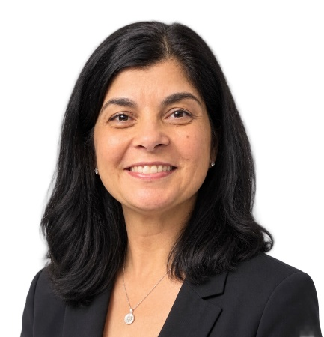
Maria Liberatore is the Itinerant Work Experience teacher for west area high schools at the York Catholic District School Board and has over 22 years of experience in Special Education, Business and Co-operative Education. She and her team developed the Pathways to EmployABILITY Program, an experiential learning program intended for students aged 16 – 21 with disabilities who require accommodations to overcome barriers in accessing work experience opportunities. She trains teachers on the program policies, procedures and curriculum, as well as providing the resources to support delivering the program to the students. Working closely with local employers and community partners, she connects students with disabilities to work experience placements where they can develop job skills, pedestrian and transit skills and the confidence needed to succeed after high school. Liberatore had piloted the Project SEARCH program with the City of Vaughan and continues to collaborate with businesses in offering work placements for students to suit their interests and abilities.

Adriana Juradinho: I am an Educational Studies student at York University with several years of experience working in diverse educational spaces, from experiential and museum-based learning to more traditional classroom environments. As a student diagnosed with a Learning Disability, and later ADHD, I have experienced firsthand challenges with navigating post-secondary education at my previous school. However, these experiences have shaped my interest in creating an inclusive and accessible learning space. This year, I am completing a work/study position with York University's EmpowerAbility program, where I am developing and running a mentorship program for students with lived experience of disability to help fill a gap in disability focused mentorship. My experiences, both personal and professional, have strengthened my desire to become a teacher, especially within special education.

Marya Bangash is a disability and human rights advocate with lived experience of disability and a strong commitment to advancing accessible and inclusive workplaces. She has completed a Bachelor’s degree in Human Rights and Equity Studies at York University and is currently pursuing a Human Resources certificate at Humber College, while gaining hands-on HR experience through a placement with Holland Bloorview Kids Rehabilitation Hospital. Her advocacy has included speaking at universities, community events, schools, conferences, and the United Nations’ Summit of the Future in New York City. Marya’s perspective is shaped by both lived experience and her work addressing barriers faced by persons with disabilities and racialized communities. She is particularly interested in how workplaces can move beyond reactive accommodation toward proactive systems that embed accessibility, inclusion, and equity into policies, culture, and everyday decision-making.

Kaelin Barichello is a policy professional navigating the world in a neurodivergent, chronically ill, and dynamically disabled body. They hold an Honours Bachelor of Environmental Studies from the University of Waterloo (2021), and recently obtained their MA in Public Policy and Administration from Toronto Metropolitan University. Between degrees, they spent three years performing policy, government relations, and stakeholder management work in the non-profit sector.
Their graduate studies included examining disability policy in relation to labour and the limitations of individualized accommodation as a means of guaranteeing equal access. They are particularly interested in how challenges with disability inclusion in public service workplaces may perpetuate indirect barriers to employment in areas such as education, transportation, and housing, in turn limiting the available pool of disabled professionals who could address them.
Kaelin currently works as a Junior Project Coordinator in the Ontario Public Service, where they began as a co-op student. They are speaking on this panel in a personal capacity, and their views are their own. They look forward to sharing their personal thoughts on how employers can be proactively disability-inclusive, drawing on their academic background and personal experience in workplaces of different sizes and cultures.

Brody Del Bove: I’m 19 years old, and right now I’m a student at Humber Polytechnic in the General Arts and Science program. During high school, I had the opportunity to do my co-op placement at Toro Aluminum working in the glass manufacturing department. I really enjoyed the hands-on work and ended up returning to work there as a summer job for two consecutive years. Working on the plant floor taught me a lot about hard work, safety, and being a dependable teammate. Most importantly, it showed me how to follow through on jobs from start to finish. That hands-on experience didn't just teach me practical trade skills—it actually made me a better, more focused student when I returned to class and gave me the confidence I need for whatever comes next.
I also live with a mild learning disability, which means school hasn’t always been easy and I sometimes have to process things a bit differently. But having a learning disability has taught me patience, resilience, and how to advocate for what I need to succeed. It taught me that just because you learn in your own way doesn’t mean you can’t get the job done right.
I’m really excited and proud to be a panelist at the Symposium today. I’m looking forward to sharing my story about balancing school, hands-on work, and neurodiversity, and showing that practical experience can open some great doors.


Rianne Matthias is an undergraduate student, community leader and advocate for disability inclusion, racial equity and meaningful youth participation. She is pursuing a double major in Global Health and Environmental Biology at the University of Toronto. Drawing on her lived experience as a neurodivergent young person, she advocates for more accessible education and workplaces, and for youth to have a voice in shaping the systems that affect their lives.
Her experience spans office administration, student support and environmental research. She currently works as an Office Administrator in the Hart House Events Office and has held peer leadership and advising roles with U of T’s Accessibility Services. She also contributed as a research assistant to a collaborative study examining how Toronto foodservice businesses could reduce their use of single-use foodware.
Alongside her employment and studies, Rianne has served on the Advisory Council of the Youth Alliance for Intersectional Justice and is Co-Chair of the Hart House Student Farm Committee. Her community leadership includes student engagement, accessible programming and participation in university governance.
In 2026, Rianne addressed the United Nations Permanent Forum on People of African Descent as a delegate with the Organization for Economic Development and Diplomacy. She highlighted how racism and ableism intersect across education, employment and civic life, calling for young people with disabilities to help shape the policies and systems that affect their futures.

Alec Farquhar is a lawyer with a long career in workers’ compensation and occupational health and safety law. He is the past co-lead of IDEA’s Engagement Activity Area and currently holds the position of Strategic Advisor to the initiative. Before retiring from public service in 2018, Farquhar was Director of the Office of the Worker Adviser at the Ontario Ministry of Labour, Immigration, Training and Skills Development (MLITSD) for six years, Managing Director at Occupational Health Clinics for Ontario Workers for five years, and Director of the Occupational Health and Safety Branch at the MLITSD for two years. In those roles, he worked extensively with vulnerable worker communities such as immigrant workers, women and young workers, and partnered with the employer community around dispute resolution, health and safety, and employment and retention of workers with disabilities.

Eve Adams is the President & Executive Director of the Canadian Business Disability Inclusion Network (CBDIN). As a skilled strategist and connector, Adams has led nationwide advocacy campaigns, driven legislative changes, and forged multi-sector partnerships to create meaningful change. Adams brings over 15 years of passionate leadership experience in consulting, public affairs, government relations, and nonprofit management. Her career spans federal, provincial, and municipal governance, including her roles as a Member of Parliament and City Councillor in Mississauga. Throughout her career, she has championed community development, accessibility initiatives, and policy reforms that have left a lasting impact. She created Canada’s priority hiring program for military veterans. She is a Director of the Haldimand War Memorial Hospital and a past Director of Enersource Corporation, the Living Arts Centre, the Toronto Red Cross and the Toronto Regional Conservation Authority.

Monique Gignac is the Scientific Director and Senior Scientist at the Institute for Work & Health. She is also a professor at the University of Toronto's Dalla Lana School of Public Health. Gignac’s research expertise is in the areas of health and social psychology, including health models of disability. Of particular interest is research on workplace communication, privacy, support and accommodation needs among individuals living with chronic, episodic conditions. Gignac has received recognition for her research, including an inclusive design award from MaRS-CIBC in 2022 for the development of the Job Demands and Accommodation Planning Tool (JDAPT), and a Queen Elizabeth II Diamond Jubilee Award (2013) She holds a Ph.D. and an M.A., both in Social Psychology from the University of Waterloo, as well as a B.Sc. in Psychology with High Distinction from the University of Toronto.

Joanna Goode is a non-profit leader with close to 30 years of experience building organizations, teams, and systems that work better for the people they're meant to serve. She currently serves as the Executive Director of the Canadian Association for Supported Employment, a national association working toward a Canada where persons with disabilities have full access to achieve and progress in meaningful employment or entrepreneurship. Before that, Goode led Facilitation Wellington Dufferin, a regional non-profit supporting people with disabilities to plan for and build the lives that they want in community.
Much of her career has centered on the disability community specifically, and that experience has shaped how she thinks about inclusion, access, and what it takes to build organizations that genuinely serve the people they exist for. Her academic background includes a Master of Leadership and Community Engagement, an Honours BA in Exceptionality in Human Learning, and a certificate in Voluntary and Nonprofit Leadership.

Erica Ruth Kelly is the Director of Learning and Development at CASE. She’s been working in the non-profit sector for over a decade and is passionate about fostering inclusive workplaces and trauma-informed support.


Amanda Klarer is a strategist, researcher and program developer with more than 20 years of experience working across sustainable development, community-based initiatives, food systems, workforce development and systems change. She currently works with Keepers of the Circle, where her work supports Indigenous-led initiatives focused on creating pathways for Indigenous women and Two-Spirit people in the skilled trades, training and housing.

Rebecca Gewurtz is an occupational therapist and Associate Professor in the School of Rehabilitation Science at McMaster University and Adjunct Scientist at the Institute for Work and Health. She is IDEA’s Director and co-lead of Hub 2, Employment Support Systems.
Gewurtz’s research focuses on work disability policy, income insecurity and employment among persons living with disabilities, with a focus on mental illness and other episodic disabilities. She has been examining the experiences of various stakeholders including people with disabilities, service providers, co-workers and employers as people with disabilities are hired and accommodated in diverse workplaces, as well as the impact and coordination of income security benefits.
She holds a PhD and an MSc in rehabilitation science from the University of Toronto. She also holds a BSc (Hons) in occupational therapy from Queen’s University. Gewurtz completed a collaborative program through the CHSRF/CIHR Training Centre in Health Services and Policy Research.

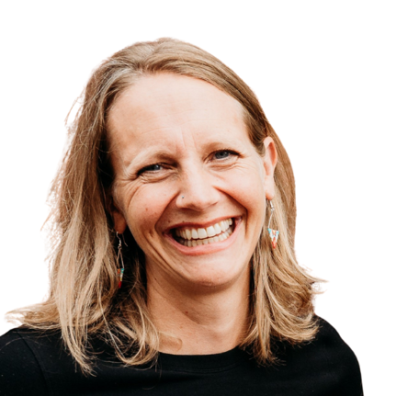
Anna Nelson is the Director of Employment Supports at LiveWorkPlay, where she leads initiatives that create pathways to meaningful employment for people with intellectual disabilities and autistic job seekers. Since joining LiveWorkPlay in 2017, Nelson has been at the forefront of advancing inclusive hiring practices, working closely with public and private sector employers to turn awareness into action. Before her current role, Nelson held leadership positions across the developmental services sector in Toronto, Ottawa, and Thunder Bay, and also taught in the Developmental Services Worker program at Confederation College. She holds a B.A. in Psychology from McGill University and a Master of Education in Community Rehabilitation and Disability Studies from the University of Calgary. Nelson believes that true progress in inclusive employment is measured not only by opportunities created but by seeing individuals thrive and grow within their roles. This belief fuels her daily work to dismantle barriers and foster lasting workplace inclusion. Beyond her professional life, Nelson is the mother of two active children and an avid outdoors enthusiast who enjoys cross-country skiing, trail running, hiking, camping, canoeing, and exploring the wilderness.
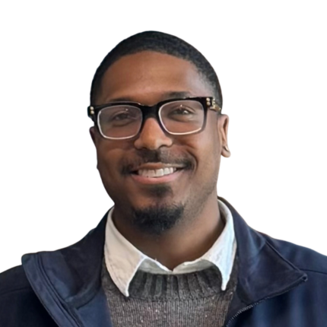
Joel Cummings is an Occupational Therapist Assistant and Physiotherapist Assistant (OTA&PTA) and Fitness & Health Promotion graduate. He has experience supporting individuals in rehabilitation and community-based settings, with a focus on functional independence, therapeutic exercise, patient-centered care, and helping individuals build the skills and confidence needed to participate more fully in their daily lives. Cummings currently serves as a Workplace Accommodation Specialist, where he supports an Inclusive Co-op Program by helping individuals develop job-readiness skills and creating more inclusive work environments. Cummings is passionate about rehabilitation, accessibility, inclusion, and creating meaningful opportunities for individuals to participate and thrive in their communities.
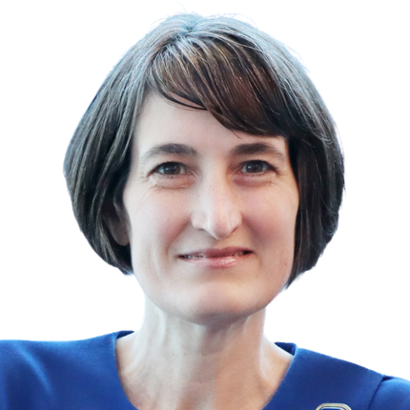
Emily Arrowsmith is the Director of Research and Programs at the Canadian Apprenticeship Forum (CAF). Over the past 19 years, Arrowsmith has undertaken a broad range of research projects and has worked with apprenticeship partners across Canada to help promote apprenticeships and careers in the skilled trades. Prior to joining CAF, Arrowsmith has conducted research and was an instructor at Algonquin College, Carleton and Trent Universities. She has a B.A. and M.A from the University of Waterloo, a Ph.D in Canadian History from Carleton University, and a Bachelor’s in Adult Education from Brock University.
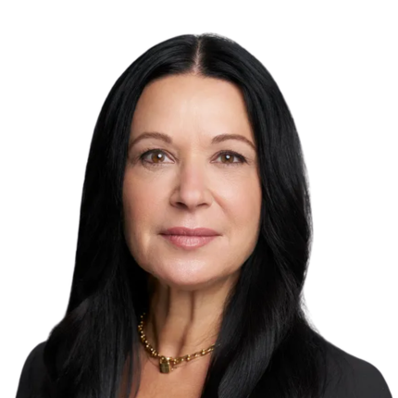
Tracy Luca-Huger is the Executive Director at Mentor Canada, a national registered charity dedicated to convening across sectors to build and accelerate the field of mentoring in Canada. The organization is leading Canadian research in mentoring, and is advancing knowledge, resources and tools to build a thriving mentoring eco-system.
Tracy holds an MA in Counselling Psychology from Gonzaga University and is a Certified Canadian Counsellor. She has held executive leadership roles in the social impact and charitable sectors and has been a consultant to mentoring programs and organizations across Canada.
Leading Mentor Canada, Tracy is passionate about creating meaningful connections, building strong, effective strategic alignments and solutions to tackle barriers to quality mentoring opportunities for Canadians and young people across this country. By working alongside governments, industry, schools, academic institutions, and cross sector organizations, at local, regional and national contexts Mentor Canada is scaling and accelerating world-class mentoring in Canada. Tracy and her team are focused on addressing the Mentoring Gap and supporting the advancement of quality mentoring, removing barriers to mentoring opportunities that embrace and meaningfully engage equity deserving youth through a thriving mentoring field in Canada.

W. Francis Fung is the National Manager, Rehabilitation and Clinical Services at March of Dimes Canada, a charitable organization dedicated to supporting people with disabilities. He leads IDEA's engagement activities and co-leads IDEA’s Hub on Employment Support Systems. Fung has overseen various pre-employment services in the private and public sector designed for low-income residents, new immigrants, individuals who have experienced homelessness, and people with a wide range of disabilities. Fung has 20 years of practical experience in psychometric testing, extensive knowledge in program development, and formal training in research methods, leadership and management. Fung has a master’s in education, community rehabilitation and disability studies from the University of Calgary, and a BSc in psychology from Trent University. He holds several designations and certifications related to vocational rehabilitation and evaluation, as well as disability management.
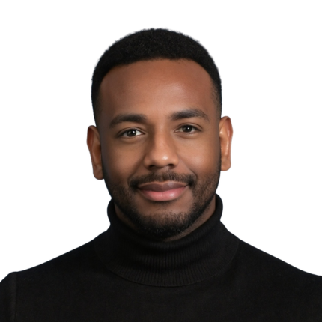
Krys Munnings is the Senior Engagement & Partnership Officer for the 4DY (For Diverse Youth) initiative, where he builds and advances partnerships with employers, industry, post-secondary institutions, and community organizations. He also produces the IDEA|4DY
Podcast Series, translating insights from
research, practice, and lived experience into
engaging conversations that inform action
toward more inclusive and accessible workplaces. Prior to joining 4DY, he served at Keyano College in progressive leadership and academic roles. As Senior Advisor, Equity, Diversity, Inclusion & Belonging (EDIB), he led the development of the College’s first EDIB Action Plan and Employment Equity Assessment and advanced trauma-informed, intersectional approaches to campus policy and support services.
Munnings' governance and EDIB advocacy experience includes serving with the International Network of Tomorrow’s Leaders under the Canadian Bureau for International Education, as well as contributing to institutional governance through roles on Memorial University of Newfoundland’s Board of Regents and McMaster University’s President’s Advisory Committee for Building an Inclusive Community (PACBIC). He also founded Memorial University of Newfoundland’s first Black Student Caucus, creating space for representation and advocacy for Black student voices. Munnings holds a Master of Arts in Sociology with a concentration in Social Psychology from McMaster University and a Bachelor of Arts in Psychology from Memorial University of Newfoundland.
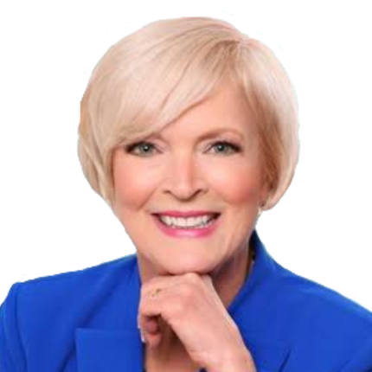
Ruth Ann Onley: Married to the late David C. Onley, the 28th Lieutenant Governor of Ontario from 2007 to 2014, Ruth Ann embraced her public role with enthusiasm. She flew into Northern Indigenous communities, on David’s behalf, to continue his Aboriginal Literacy programs. In 2008, Ruth Ann and David had the honour of meeting the Queen at Buckingham Palace.
Ruth Ann has also enjoyed a career as a professional musician for over 40 years, including winning the Canadian Country Music Newcomer of the Year Award in 1982. She has performed at countless events and concerts, including performing the National Anthem for the Toronto Blue Jays, accompanying orchestras and performing for eager fans at various festivals.
Ruth Ann is the recipient of an honorary Doctor of Literature degree from Canada Christian College, the Queen’s Diamond Jubilee Medal and the King Charles III Coronation Medal.

