\**Profiles appear in the order in which presenter names appear in the agenda.*

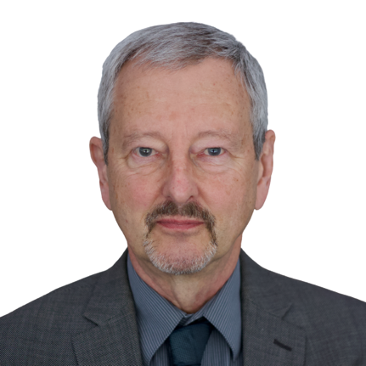Alec Farquhar is a lawyer with a long career in workers’ compensation and occupational health and safety law. He is the past co-lead of IDEA’s Engagement Activity Area and currently holds the position of Strategic Advisor to the initiative. Before retiring from public service in 2018, Farquhar was Director of the Office of the Worker Adviser at the Ontario Ministry of Labour, Immigration, Training and Skills Development (MLITSD) for six years, Managing Director at Occupational Health Clinics for Ontario Workers for five years, and Director of the Occupational Health and Safety Branch at the MLITSD for two years. In those roles, he worked extensively with vulnerable worker communities such as immigrant workers, women and young workers, and partnered with the employer community around dispute resolution, health and safety, and employment and retention of workers with disabilities.

Sinead McCarthy is Vice President of Development, Programs and HR at Youth Employment Services (YES), a national agency that offers employment counselling, training and placement programs for disadvantaged and vulnerable youth in Canada. She joined YES in 1999, where she was previously Vice-President, Administration and Special Projects. McCarthy co-leads IDEA’s Hub on Transitions to Work and Career Development. Sinead has a BSocSc from University College Cork, a Certificate in Labour Relations from Sheridan College and a Certificate in Financial Management for Non-profits from the Chang School of Continuing Education at Toronto Metropolitan University. She is currently working toward a Certified Human Resources Leader (CHRL) designation.

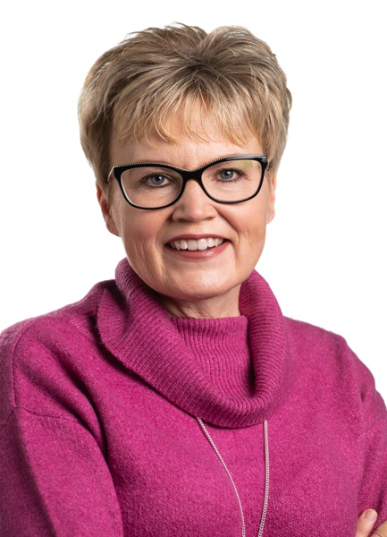Krista Carr is a long-time advocate in the inclusion movement, with over 25 years of experience in the non-profit sector as a champion of inclusion. She is IDEA’s Advisory Committee Chair and the Executive Vice President (CEO) of Inclusion Canada, one of Canada’s 10 largest charitable organizations. She is responsible for leading the Inclusion Canada National organization, the Inclusion Canada Foundation, Inclusive Education Canada (IEC). Carr is a graduate of the University of New Brunswick (UNB) where she earned a bachelor’s in business administration (BBA) and several diplomas in Human Resources and Management from UNB’s College of Extended Learning. She is fluently bilingual and works on behalf of CACL’s federation in both French and English. She currently resides in New Brunswick with her husband and two daughters.

Emile Tompa is the is Executive Director of IDEA, co-lead of IDEA’s Hub on Workplace Systems and Partnerships, and a Senior Scientist at the Institute for Work & Health (IWH). A labour and heath economist, Tompa holds appointments as Associate Professor in the Department of Economics at McMaster University and as Assistant Professor at the Dalla Lana School of Public Health at the University of Toronto. Tompa’s current research focuses on analyzing the nature and impact of disability, health and safety systems, conducting economic evaluations of workplace interventions for primary and secondary prevention, and understanding the impact of labour market experiences on health and well-being. Tompa has a PhD in labour and health economics from McMaster University, an MBA from the University of British Columbia, and an MA in economics from the University of Toronto.

Rebecca Gewurtz is IDEA’s Director, co-lead of IDEA’s Hub on Employment Support Systems, an occupational therapist, and Associate Professor in the School of Rehabilitation Science at McMaster University. She is an Adjunct Scientist at the Institute for Work and Health. Gewurtz’s research focuses on work disability policy, income insecurity and employment among persons living with disabilities, with a focus on mental illness and other episodic disabilities. She holds a PhD and an MSc in rehabilitation science from the University of Toronto. She also holds a BSc (Hons) in occupational therapy from Queen’s University. Gewurtz completed a collaborative program through the CHSRF/CIHR Training Centre in Health Services and Policy Research.

Melissa (Missy) Fishmanis a 2-Spirit woman of the Thunderbird clan, raised in treaty 13 and a member of Lillooet Valley F.N. She works at the 2-Spirited People of the 1st Nations as an educator and community collaborator sharing her passion for fostering inclusive spaces, advancing meaningful reconciliation, and strengthening collective understanding of Indigenous and 2-Spirit resilience.

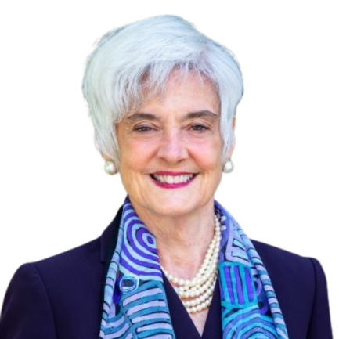Susanne M. Bruyère, Ph.D., CRC, is a Professor of Disability Studies and Academic Director of the *K. Lisa Yang and Hock E. Tan* Institute on Employment and Disability, Cornell University ILR School, Ithaca, NY. The Institute is a research, training, and technical assistance center focusing on disability inclusion in employment, education, and community. Bruyère serves as Institute administrative/strategic lead, and as the PI/Co-PI of research, dissemination, and technical assistance efforts focused on employment disability policy and effective disability workplace practices. She is the PI/Project Director of the National Policy, Research, and Technical Assistance Center on Employment of People with Disabilities funded by the U.S. DOL Office of Disability Employment Policy. She is the author/co-author of five books and over 180 peer-reviewed articles and book chapters on workplace disability inclusion. Bruyère holds a doctoral degree in Rehabilitation Counseling Psychology from University of Wisconsin-Madison and is a Fellow in the American Psychological Association.

Andrew Dixon is an interdisciplinary PhD candidate at Memorial University in St. John's, Newfoundland, specializing in neurodiversity and developing more inclusive workplaces. He is a research associate with IDEA Hub on Workplace Systems and Partnerships. Dixon holds a master’s in philosophy (Humanities) from Memorial University and a BA in history from the Royal Military College. Dixon is skilled in qualitative methods and evidence synthesis. His PhD work primarily focuses on ethnographic approaches to social justice and disability rights. He is a recipient of a MITACS fellowship to study the Disability Tax Credit system and a Florence Fox Memorial Scholarship to study the social impact of Parkinson’s disease. Dixon has lived experience with neurodiversity and invisible disability. Outside of IDEA and academia, Dixon is involved in several advocacy initiatives with marginalized disability communities that focus on better living conditions. Dixon's commitment to community service is evident through his active volunteerism with Scouts Canada and the Autism Society of Newfoundland.

Peter Field is an Accessibility and Inclusion consultant living in British Columbia. In 2019 he retired from a 28-year career with Canada’s federal Public Service. Since then, he has worked on projects with the Province of British Columbia, the Rick Hansen Foundation, the CNIB Research Team, and the National Network for Equitable Library Service. In his not so much spare time, he leads the Triple Vision podcast team in developing monthly podcasts on issues of blindness in Canada.

Matt Freeman is an Assistant Clinical Professor, McMaster University where he has worked in the School of Rehabilitation Science since 2007 in various roles. Freeman’s research interests include information needs during the transition to adulthood for youth with disabilities and their families, including employment. Since the pandemic, Freeman has also explored a program of research examining the development, implementation and impact of COVID-19 related infection control policies in congregate care settings in the developmental services sector in Ontario under the leadership of Dr. Briano Di Rezze.

Andy Livingston is the CEO of Dexterity Consulting. He is passionate about making dispute resolution accessible for all. His expertise, mediation skills and work on accessibility and accommodation issues are highly sought after. Over the last 20 years, Livingston's career focused on helping people improve their citizenship within society by allowing them greater levels of participation within their chosen communities. Livingston brings a unique perspective of lived experience to his work. As a wheelchair user, he can easily relate to people with disabilities and to organizations trying to improve accessibility at all levels. He has a Double Honours Bachelor of Arts in Political Science and Sociology and a master’s degree in Sociology from the University of Saskatchewan.

****Mahadeo Sukhaiis the world’s first congenitally blind geneticist. He is the COO of IDEA STEM and holds adjunct faculty appointments at University of Ontario Institute of Technology, Queens University, and OCAD University. Sukhai chairs the Employment Technical Committee for Accessibility Standards Canada. He is the external co-chair of the Canadian Institutes of Health Research (CIHR) Expert Advisory Committee on Accessibility and Systemic Ableism. He also serves on the Boards for Health Data Research Network Canada and the Institute of Neurodiversity Canada, and is a member of the steering committee for Disability and Work in Canada. Sukhai has a PhD in medical biophysics and a PhD in cancer genetics, both from the University of Toronto. Sukhai co-leads IDEA’s Hub 4, Inclusive Environmental Design.

Don Gallant in the National Director of Ready, Willing & Able — an initiative of Inclusion Canada and the Autism Alliance of Canada that aims to increase the labour force participation of persons with intellectual disabilities and on the autism spectrum. He is also Principal Consultant with Don Gallant and Associates, an agency providing support and consultation to advance and promote social well-being and inclusion, especially for persons with disabilities. Gallant co-leads IDEA’s Hub on Workplace Systems and Partnerships. Prior to entering the private sector in 1998, Gallant held senior management positions with the Government of Newfoundland and Labrador (NL). During his tenure as Director, Division of Family and Rehabilitative Services in NL, he was involved in the development of a comprehensive array of community-based programs and supports for persons with disabilities and their families, including the introduction of a supported-employment model within the province.

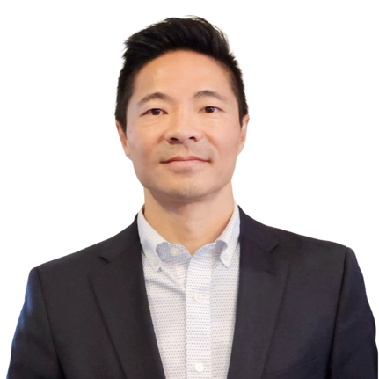 W. Francis Fung is the National Manager, Rehabilitation and Clinical Services at March of Dimes Canada, a charitable organization dedicated to supporting people with disabilities. He leads IDEA's engagement activities and co-leads IDEA’s Hub on Employment Support Systems. Fung has overseen various pre-employment services in the private and public sector designed for low-income residents, new immigrants, individuals who have experienced homelessness, and people with a wide range of disabilities. Fung has 20 years of practical experience in psychometric testing, extensive knowledge in program development, and formal training in research methods, leadership and management. Fung has a master’s in education, community rehabilitation and disability studies from the University of Calgary, and a BSc in psychology from Trent University. He holds several designations and certifications related to vocational rehabilitation and evaluation, as well as disability management.

Arif Jetha is Associate Scientific Director and Scientist at the Institute for Work & Health (IWH), an applied, not-for-profit research organization based in Toronto, Canada. He is also Associate Professor at University of Toronto’s Dalla Lana School of Public Health. Jetha co-leads IDEA’s Hub on Transitions to Work and Career Development. Jetha’s program of research aims at understanding how sociopolitical, technological, environmental and economic changes that characterize the future of work affect the health and employment participation of vulnerable workers. He is also interested in understanding how changing working conditions can shape the labour market experiences of youth and young adults living with disabilities and chronic disease at the early career phase and across the life course. Jetha earned his PhD in behavioural sciences and public health at the University of Toronto, and an MSc in health community and development from the London School of Economics and Political Science.

Dan Samosh is an Assistant Professor, Employment Relations Studies at Queen’s University and an Adjunct Scientist at the Institute for Work & Health. He co-leads IDEA’s Hub on Transitions to Work and Career Development. Prior to his posting at Queen’s, Samosh was a Post-Doctoral Researcher at the Institute for Work & Health and at the Centre for Industrial Relations and Human Resources at the University of Toronto. Samosh’s current research looks at the work experiences of persons with disabilities, with a particular focus on the leadership emergence of persons with disabilities, disability stigma and social identity, and workplace inclusion of persons with disabilities. Samosh earned his PhD in organizational behaviour and MSc in management at the Smith School of Business at Queen’s University.

Jordana Maisel is an Associate Professor in the Department of Urban and Regional Planning, and the Research Director of the Center for Inclusive Design and Environmental Access (IDEA Center), both within the School of Architecture and Planning at the University at Buffalo. She co-leads IDEA’s Hub on Inclusive Environmental Design. Maisel has led research in the areas of public transportation, street infrastructure, post-occupancy evaluations and accessible housing policy. She directs the U.S. government-funded Rehabilitation Engineering Research Center (RERC) on Universal Design and the Built Environment and co-directs the RERC on Accessible Public Transportation. Maisel has a PhD in industrial and systems engineering and an MUP (Master’s of Urban Planning) from the University at Buffalo. She also has a BSc in human development from Cornell University.

Jimin Choi is a Postdoctoral Associate at the Center for Inclusive Design and Environmental Access (IDEA Center) in the School of Architecture and Planning at the University at Buffalo. She is part of IDEA's Hub on Inclusive Environmental Design under the supervision of Jordana Maisel. Choi's research is dedicated to promoting equity and inclusion for underrepresented populations by enhancing access to transportation and creating more inclusive built environments. Choi earned her PhD in Urban and Regional Planning from the University at Buffalo and has a master’s degree in landscape architecture from Seoul National University and a bachelor’s degree in architecture from Yonsei University in Korea.

Angelika Seeschaaf-Veres is an Associate Professor, Industrial Design and Graduate Studies at OCAD University. She is also Co-Director of Radical Norms, a boutique design research consultancy that helps international Fortune 300 companies develop strategies for uncertain futures. She co-leads IDEA’s Hub on Disruptive Technologies and the Future of Work. A designer, educator, researcher and critical future foresight strategist, Seeschaaf-Veres’ current research explores the potential and impacts of technologies, particularly around artificial intelligence (AI), on the future of work for profit and not-for-profit organizations. Her work highlights the perpetuation of assumptions and bias and their impact on people living with differences. Seeschaaf-Veres has an MA in product design from the Royal College of Art, a diploma in industrial design from the Berlin University of the Arts, and a BA (Hons) in design products from Ravensbourne University London.

Alfred MacLeod was appointed to the position of Assistant Deputy Minister of Public Service Accessibility at Treasury Board of Canada Secretariat in October 2018. From 2017 to 2018, McLeod was Assistant Deputy Minister at Public Services and Procurement Canada, where he oversaw the Canada Post Corporation Review. Previously, McLeod was Assistant Deputy Minister of PSPC’s Policy, Planning and Communications Branch. Other experience includes a 2-year Executive Interchange with CBC/Radio-Canada as Executive Director of Corporate Affairs, as well as previous Assistant Deputy Minister positions at the Privy Council Office and Citizenship and Immigration Canada. Before joining the federal public service, McLeod was Senior Vice-President, Public Policy, at EKOS Research Associates Inc. Alfred holds bachelor’s degrees in history and education from Acadia University, and a MPhil (Politics) from the University of Exeter. He is a graduate of the Australia and New Zealand School of Government’s Executive Fellows Program.

Nadine Charron is the Executive Director of the Accessibility, Accommodation, and Adaptive Computer Technology (AAACT) Program at Shared Services. With a wealth of experience in the field, Charron has dedicated her career to advancing accessibility and inclusion in various environments. Throughout her career, Charron has been a passionate advocate for the rights of individuals with disabilities, championing innovative solutions that enhance their access to technology and services. Her leadership has not only transformed organizational practices but has also inspired countless professionals to prioritize accessibility in their work. Charron’s commitment to fostering inclusive communities and her expertise in adaptive technology make her a sought-after speaker. She brings valuable insights and practical strategies for creating environments where everyone can thrive. Her work continues to make a significant impact, paving the way for a more equitable future. Charron holds a master’s degree in leadership and Adult Education, equipping her with the skills to drive meaningful change and empower individuals.

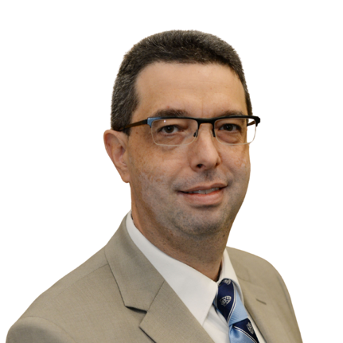André Baril is the Director General of Accessibility and Disability Inclusion Projects in the Office of the Deputy Minister Champion for Federal Employees with Disabilities. André has over 26 years of experience in policy and operations in the Government of Canada. From 2022 to 2024, he was Director General of Aviation Security at Transport Canada. Prior to this role, he held various executive positions at Immigration, Refugees and Citizenship Canada (IRCC). Over the past 5 years, he supported the restart of the aviation system and the decongestion of airports, led the establishment of *Verified Traveller* lines at major airports, the re-engineering of immigration services in response to COVID, COVID border restrictions and exemptions, and he coordinated IRCC’s efforts in evacuations out of Afghanistan during the air bridge closure. André is visually impaired and is a federal employee with lived experience of disability. From 2017 to 2024, he was Chair and Champion of IRCC’s and Transport Canada’s networks for persons with disabilities. He has a master’s degree in economics from the University of Toronto and a bachelor’s degree in economics from Université de Montréal (with a one-year exchange at the University of British Columbia). He is passionate about disability inclusion and is a proud father of three sons.

Angela Wellman has worked in the federal government for nearly 20 years, with the last 15 focused specifically on accessibility and inclusion. She is currently the manager of the Workplace Inclusion and Accessibility Centre at the Office of Public Service Accessibility (TBS) designing solutions that reflect the Government of Canada’s commitment to inclusivity and respect for human dignity. She has a bachelor’s degree in political science and modern languages, and a master’s degree in Ethics.

Ashvene Sureshkumar is a PhD Candidate at the University of Toronto within the Rehabilitation Sciences Institute (RSI). She is a research associate in IDEA’s Hub on Workplace Systems and Partnerships, working under the direction of Emile Tompa and Emma Irvin. Sureshkumar is skilled in evidence synthesis, qualitative methodologies, quantitative methodologies and mixed methods. She has experience with equity, diversity, inclusion and accessibility (EDIA) research and her areas of research expertise include mixed methods, mindfulness-based interventions, health services research and people living with multiple sclerosis. Her PhD work involves developing an implementation toolkit for building online mindfulness-based interventions for people living with multiple sclerosis. Sureshkumar holds a Bachelor of Health Science (BHSc) and a Master of Science (MSc) in Health and Rehabilitation Sciences from Western University. In 2024, Ashvene was awarded the endMS Doctoral Student Award to support her doctoral research.

Mayor Mike Bradley was elected to Sarnia Council in 1985 and elected Mayor in 1988. In 2022 he was re-elected for an 11th term. Prior to this he was Executive Assistant to the late Hon. Justice Bud Cullen, MP for Sarnia Lambton (1930-1985). Mayor Bradley currently serves as Chairman of the Board for the University of Western Ontario Research Park (Sarnia Campus). He has championed civil liberties, security and environmental issues and has been an advocate on many other social and economic issues. Mayor Bradley has been awarded the Queen's Golden Jubilee Medal and the Queen's Diamond Jubilee Medal for significant contributions to Canada and achievement. He appeared in Michael Moore's "Bowling for Columbine". Mayor Bradley is a frequent media commentator on local, provincial, national and international issues. A long-time Bruce Springsteen fan, he contributed to two books about Springsteen in 2OO7 and 2OO9—“For You" and "The Light in the Darkness"—by Lawrence Kirsch.

Wendy Cukier is the Director of the Diversity Institute at Toronto Metropolitan University. She is also the Academic Director of Women Entrepreneurship Knowledge Hub, the Academic Research Director of the Future Skills Centre and an Ecosystem Partner for The 50-30 Challenge. Cukier is one of Canada's leading experts in disruptive technologies, innovation processes and diversity. Cukier has written more than 200 papers on technology, innovation and management and is coauthor of the bestseller “Innovation Nation: Canadian Leadership from Java to Jurassic Park.” Cukier has assisted organizations in becoming more inclusive through innovative programs such as DiversityLeads funded by the Social Sciences and Humanities Research Council, which tracks the progress, impediments and evidenced-based strategies for promoting diversity and inclusion in organizations. Cukier holds an MA and MBA from the University of Toronto, a PhD from the Schulich School of Business, York University. She has also received an honorary doctorate from Laval University in medicine, dentistry and nursing and an honorary Doctor of Laws from Concordia University.

Karen Harlos is a professor and past Inaugural Chair of the Department of Business and Administration at the University of Winnipeg. She is lead of IDEA's Equity, Diversity, Inclusion and Accessibility Activity Area. Harlos’s expertise is in organizational behaviour, organizational psychology, psychometrics and human resources. Her research focuses on workplace bullying and mistreatment, employee silence and voice in the face of mistreatment, and workplace issues in healthcare. Harlos co-authored a teaching case on workplace mistreatment that won the Outstanding Compact Case Competition Winner at the international 2022 Case Centre Awards. (Case Centre, established in the U.K. in 1973, is an international not-for-profit that promotes “the case method” as an essential part of management education in business schools.) Harlos has a PhD in organizational behaviour, an MA in organizational/industrial psychology and a BA in clinical psychology, all from the University of British Columbia.

Bilan Arte is a Black, Muslim feminist living and working in the unceded and never surrendered traditional territories of the Anishinabewaki and Omàmìwininìwag people. Arte is an award-winning activist and organizer with over a decade of experience in campaigns, leadership, and movement building, from youth led to trade union organizing. Arte is the National Representative, Human Rights at the Canadian Labour Congress. In all aspects of her work, Arte is fuelled by her passions for social justice and equity. Her commitment to disability justice and building an accessible society for all is why she is thrilled to represent the CLC as part of the IDEA Project and sit on its advisory committee.

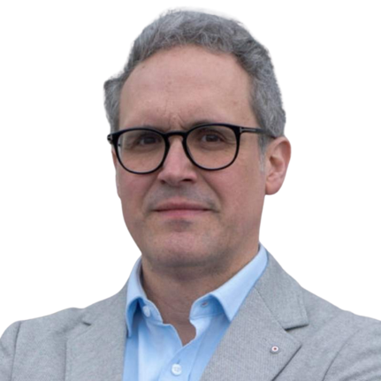Rafael Gomez is a professor of employment relations and, since 2015, Director of the Centre for Industrial Relations and Human Resources at the University of Toronto. He is co-lead IDEA’s Training and Skills Development Activity Area. Gomez’s current research examines the role of unions and other labour market institutions in providing the employee voice, and what this means for workers and broader democratic engagement. In 2005, Gomez was awarded the U.S Labor and Employment Relations Association’s John T. Dunlop Outstanding Scholar Award for exceptional contributions to international and comparative labour and employment research. In 2013-14, his book The Little Black Book for Managers was a U.K. business book business bestseller. His second book, Small Business and the City, was published in 2015. Gomez earned a PhD and an MA in industrial relations, as well as an MA in economics, from the University of Toronto. He got his BA in economics and political science from Glendon College at York University.

Brian Foster is the National Manager – Policy and Resource Development at Ready Willing and Able (RWA). He has a diverse background in the social sciences, communications, media, politics, not for profit operations, and academia. Brian has worked as a consultant, professor, policy analyst, and director or manager, with his work focused on disability and the labour market, provincial disability policies and supported housing for the last decade. As the National Manager of Policy and Resource Development, Brian spearheads the creation of resources for Ready, Willing and Able and The Inclusive Workplace. He enjoys collaborating and engaging in discussions on inclusive employment policies from the local to the international.  Brian has a PhD in history and social sciences from Carleton, and a master’s from Western University, as well as a wealth of strategic and operational experience spanning not for profits and private sector work over 17 years.

Jonathan Lai is the Executive Director at Autism Alliance of Canada (formerly, Canadian Autism Spectrum Disorder Alliance). He holds an adjunct faculty position in Health Services Research at the Institute of Health Policy, Management and Evaluation (IHPME) in the Dalla Lana School of Public Health at the University of Toronto. Lai's current work involves building consensus among stakeholders by responding to emerging gaps in the sector and being a constructive policy idea generator to guide the development of Canada’s Autism Strategy. He is responsible for running all facets of the organization. Lai is passionate about systems change and real-world collective impact. He has built bridges between evidence, practice, and policy by running TEDx events, hosting national Summits, facilitating policy tables, conducting research and program evaluations.



Charlotte Buttle is the Associate of Research and Knowledge Mobilization at March of Dimes Canada (MODC). In her role, Buttle supports research projects and program evaluations across all departments at MODC.  Buttle is passionate about supporting community-based initiatives that harness community strengths and capacities to improve the social and ecological components of health and well-being. She holds a Master of Public Health, specializing in Health Promotion.

****Hedgerow Thompson is lived experience volunteer with March of Dimes Canada and other organizations. They contribute to projects by adding elements of personal expertise. Thompson has been living with disabilities for more than 15 years and has been volunteering and contributing to disability related projects for 6 years. Their passions include eliminating poverty, disability justice, and accessible employment.

Rebecca Coxon is the Team Lead for Employment Ontario and the Interim Volunteer Manager at LiveWorkPlay. She first joined the organization in 2015 before moving to British Columbia to explore the West Coast and gain experience in the developmental services sector. Coxon returned to Ottawa in 2017 and has since held various frontline and leadership roles within LiveWorkPlay. Most recently, she has played a key role in helping the organization navigate the Integrated Employment Services transformation. She is passionate about Asset-Based Community Development and is committed to helping communities and employers recognize the valuable contributions that people with intellectual disabilities and autism bring to workplaces and society. In her free time, Rebecca enjoys spending evenings at the dog park with her beloved Newfoundland dog, Poppy.

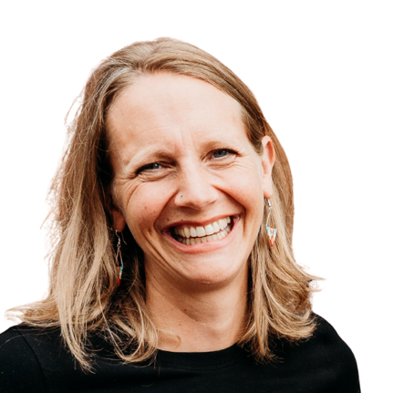**Anna Nelson** is the Director of Employment Supports at LiveWorkPlay, where she leads initiatives that create pathways to meaningful employment for people with intellectual disabilities and autistic job seekers. Since joining LiveWorkPlay in 2017, Nelson has been at the forefront of advancing inclusive hiring practices, working closely with public and private sector employers to turn awareness into action. Before her current role, Nelson held leadership positions across the developmental services sector in Toronto, Ottawa, and Thunder Bay, and also taught in the Developmental Services Worker program at Confederation College. She holds a B.A. in Psychology from McGill University and a Master of Education in Community Rehabilitation and Disability Studies from the University of Calgary. Nelson believes that true progress in inclusive employment is measured not only by opportunities created but by seeing individuals thrive and grow within their roles. This belief fuels her daily work to dismantle barriers and foster lasting workplace inclusion. Beyond her professional life, Nelson is the mother of two active children and an avid outdoors enthusiast who enjoys cross-country skiing, trail running, hiking, camping, canoeing, and exploring the wilderness.

Laura Bowman is the Project Manager in charge of Research and Evaluation for Holland Bloorview Kids Rehabilitation Hospital’s Employment Pathways. In this role, she works with clinical, community, and policy-based partners to build disability-inclusive employment practices that enable connections between youth with disabilities and the workforce. Her work includes research, program and service evaluation, and knowledge mobilization, and draws from learning health systems, developmental, and occupational science approaches.

Carolyn McDougall is the Manager of Holland Bloorview Kids Rehabilitation Hospital’s Employment Pathways, supporting 60+ high school aged youth with disabilities annually to get critical early work experiences. She is also the Business Liaison for Holland Bloorview’s co-site host role for Project SEARCH Toronto and supports coordination amongst Canada’s Project SEARCH sites. McDougall's research and community partnership interests relate to: work-based learning, transitions to adulthood, life skills, family involvement and systems coordination.

Gabriella Evans is a registered social worker and regional manager for the WorkAbility project. Her work in the inclusive employment sphere began over ten years ago after completing her Master of Social Work with Wilfrid Laurier University. Evans has been involved in various mental health and employment programs at Youth Employment Services including the Lighthouse Project and the YES Mentorship program. She is passionate about community collaboration as a response to removing structural barriers in the workforce.

Bridgette Sterling is a passionate educator and design thinker with a blended background in learning experience design, employment services, facilitation, and technology. Sterling possesses a wealth of experience in learning and development, spanning across corporate, non-profit, and higher education sectors. She has spearheaded the creation of numerous courses, programs, events, and workshops, consistently prioritizing a user-experience-centric approach to training. During her time in higher education, her efforts contributed to thousands of diverse student groups successfully securing their first career roles, achieved through innovative systems, holistic employment coaching, learner-centered instruction, and strategic industry collaborations. Prior to this, Sterling spent several years in the tech sector specializing in organizational efficiency, digital strategy, and business development. She is a MDes candidate in OCAD-U’s Strategic Foresight and Innovation program with a focus on psychological safety and foresight in youth sport culture.

Joanna Goode (she/her) is the Executive Director at Canadian Association for Supported Employment, a national membership association committed to increasing the strength and diversity of the Canadian workforce through the inclusion of people who experience disability. She has over 30 years’ experience working for and leading non-profit organizations in service to the disability community and to increasing inclusion in Canada. Goode has a Master’s of Leadership and Community Engagement from York University, as well as post grad certificates in Non-profit and Voluntary Sector Leadership and an undergraduate honours degree in Exceptionality in Human Learning.

Mary Beshai is the director of MentorAbility Canada at the Canadian Association for Supported Employment. She is an experienced leader and program manager who has lead teams in Canada and around the world in the public, private, not-for-profit, and academic sectors. Passionate about social change, accessibility, and inclusion, Beshai has participated in collaborative cross-sectoral partnerships to foster the development of innovations with and for communities facing barriers to social and economic inclusion.

Agnes McLachlan and her team are a passionate group of advocates for the importance of good health and through their award- winning well-being strategy at TELUS, they are creating opportunities for team members to become their best selves by enhancing their whole health & well-being, at home, at work and in the community. McLachlan is the Manager of Global Well-being at TELUS supporting Canadian and global operations and is responsible for supporting the well-being and mental health strategy, EFAP services, proactive well-being related initiatives and supporting disability management, all driving true culture evolution. She works strategically with leaders and our People and Culture team to truly support health and well-being.  McLachlan is a Registered Nurse, accomplished health, well-being and disability management professional and holds numerous certifications in Occupational Health and Psychological Health and Safety.