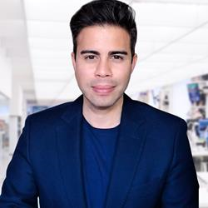
Jon Callegher (Project Director, George Brown College) Jon is a professor in the School of Marketing in the Centre for Business at George Brown College. Since 2016, he has been the Project Director for over $1.2 million in federal and provincial research projects. He has a Ph.D. in sociology from the University of Waterloo. He is also the author of Pearson Canada's new standard post-secondary Marketing Research textbook (2021).

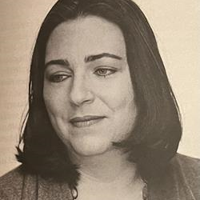
Shari Ingalls (Independent Storyteller) Born and raised in Calgary, Alberta, Shari is no stranger to major life changes. She has 3 post secondary degrees, has taught ESL in Russia, has worked as a lab technician, secretary, Chaplain and Registered Nurse. She has been living with long covid since December 2020.

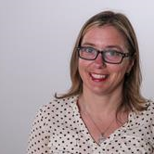
Dr. Tammy Bernasky (Assistant Professor in the Department of L’nu, Political, and Social Studies, Cape Breton University)
[No Bio]


Benjamin Millard (Project Director, Q.i. Value Systems Inc.) Benjamin plays a large role in partner relationship management and project logistics for Job Talks Access. He has worked with Dr. Callegher on Job Talks since its inception, helping to design and manage a comprehensive study on the intersection of personal values and employment.

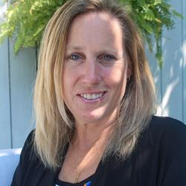
Tanya Hickey (Senior Manager: Health & Safety Strategies, Ontario Power Generation) Tanya Hickey holds a Master of Science specializing in Occupational Health & Safety from Columbia Southern University as well as a Bachelor of Science in Environmental Sciences from the University of Guelph. She is currently the senior manager of health and safety strategies at Ontario Power Generation. Hickey is accountable for providing direction around health and wellness solutions, employee assistance, and absence benefit supports to the organization through strategic planning, analysis, development, collaboration, management and evaluation of these programs that support employees across their entire health continuum. Over the last 13 years at OPG, she has lead the development and implementation of an award winning program based on leading industry practices. Hickey is a strong believer that comprehensive organizational health, wellness, benefit, and support programs, that are inclusive and accessible, can inspire people to lead healthier, happier lives and be engaged in the workplace.
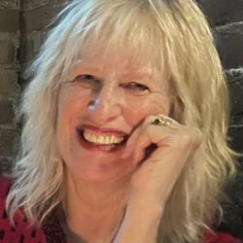
Donna Michal (Senior Consultant, Lazanik Management Services) Donna Michal works as a consultant in Victoria, BC and as an Advisor in the Special Needs Project. Donna’s recent consulting work includes supporting child care projects in First Nations and Urban Aboriginal communities and program development work on the CUPW National Disability Supports Portal.

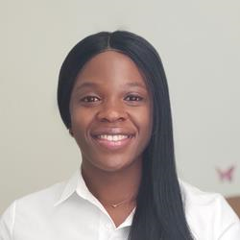
Tosin Ogedengbe (Master’s Student, Universite de Montreal) I am a master’s student in the Vision Science program at the Université de Montréal, School of Optometry. I have a bachelor’s degree in optometry, and my research interest lies in improving the quality of life of people with vision loss across their lifespans. I aim to make my work relevant beyond the clinical setting through an interdisciplinary collaboration and translational research approach. I am currently exploring my interest in the Wittich Vision Impairment Research Laboratory in collaboration with the Canadian National Institute for the Blind (CNIB) and Mitacs Canada. I am working on co-designing a tool to assess employers’ preparedness to employ people with vision loss. This project aims to ensure sustainable employment success for people with vision loss.

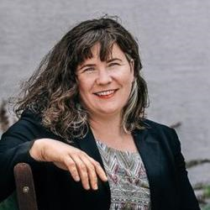
Leni Goggins (Director of Social Economy and Other Cool Stuff, Inclusion Powell River Society) Leni Goggins is Project Manager of the New Inclusive Economy and is the Director of Social Economy and Other Cool Stuff at inclusion Powell River leading projects such as qathet Inclusive Manufacturing, OneLight and Kindred ReBuild. She grew up in the qathet region where she lives now with multiple generations under one roof. She combines 20 years of experience working with people with disabilities, seniors and youth with her project management work with non-profit and socially minded enterprises.
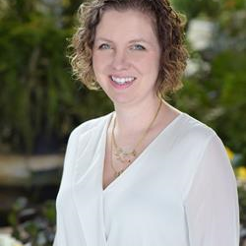
Delaney King (Owner/Founder, Ready Willing & Able [Preventative Measures Ltd.]) Delaney is passionate and enthusiastic about writing curriculum, content and training material for a purpose. She completed an eight-month certificate course through Landmark college entitled Learning Differences and Neurodiversity (LDN) and has a master’s degree in Adult Education & Global Change. She also has over ten year’s experience as an instructor and trainer working with adults in all types of environments and workspaces. Recently, she expanded to create a program called the "Building blocks for success" with neurodiverse youth in the employment sector. This program works Indigenous Communities to share learning around neurodiversity and how it can be utilized by families and individuals in the workforce.
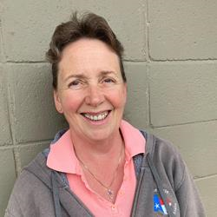
Barb MacLeod (Inclusion Powell River) Barb MacLeod was born and raised in Powell River, BC and has lived all over the province. She is visually impaired and has been all her life. She was a peer-support worker for the Canadian National Institute for the Blind. She ran a landscaping group for persons with employment barriers at formerly called Artiban (now inclusion Powell River) and in the 90s worked to develop and put into print an accessibility booklet for services and businesses in the Powell River area on behalf of Powell River Model Community Project.
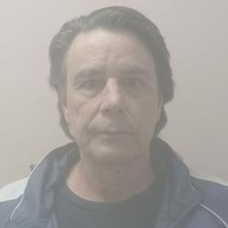
Richard Light (Floor assistant, Inclusion Powell River [Kindred Rebuild]) Richard is a floor assistant at Kindred Rebuild. He previously worked at OneLight as an employee participant. He is very interested in the principles of a circular economy and is an outdoor enthusiast. He is a self-advocate for mental wellness and works for peace.

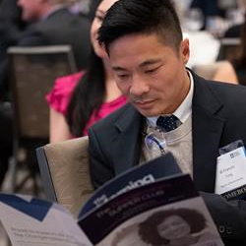
Francis Fung (National Manager, Rehabilitation and Clinical Services, March of Dimes Canada) W. Francis Fung is currently a Senior Manager at March of Dimes Canada, a charitable organization dedicated to supporting people with disabilities. His national portfolio focuses on rehabilitation, employment, and clinical services. Since 2007, Francis has worked in the non-profit sector and has had oversight of various rehabilitation and pre-employment services designed for low-income residents, new immigrants, individuals who have experienced homelessness, and people with a wide range of disabilities. He has approximately 20 years of practical experience in psychometric testing, extensive knowledge in program development and contract negotiations, as well as formal training in research methods, leadership, and management.
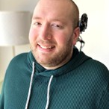
Paul VanderGriendt (Research Assistant, George Brown College) Paul is a former pilot and flight instructor, who lost the use of his arms and legs in a devastating motor vehicle accident. Needing to reset his lifestyle and goals, Paul is currently a research assistant and host for Job Talks Access, a student in Sport & Event Marketing at George Brown College, and a general problem-solver, innovator, and accessibility advocate.
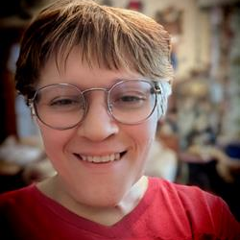
Annie Jollymore (Systemic Advocate, (PACE) People Advocating for Change through Empowerment, Inc., Ret.) Annie Kent came into her own in University, studying Psychology, and earning a Master of Arts degree at age 21. Successful employment in disability Advocacy and Education followed, until a late diagnosis of Nonverbal Learning Disability, Autism and ADHD interfered with employers' perceptions of her capabilities. "The diagnoses didn't change who I am, but altered perceptions by others of what I could do."
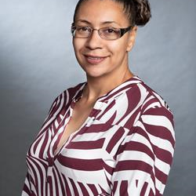
Liza Arnason (Ase Community Foundation for Black Canadians with Disabilities) Liza Arnason BA, MA in Sociology and Equity Studies in Education at UofT's Ontario Institute for Studies in Education, is the Owner of Arnason Consulting, Chair of the UCalgary Black Alumni Network, founder and Chair of the Ase Community Foundation for Black Canadians with Disabilities, and above all a mom, grandma, and mentor. Liza's commitment to the principles of "nothing without us" and "for us, by us”, has always been the cornerstone of her work as an educator, administrator, and community advocate. Her depth of knowledge and expertise is informed by her lived experiences, research and policy initiatives, and work experience over 30 years. Liza draws on critical pedagogy including Black Feminism, disability justice, and critical race theories to inform community-based research and policy change initiatives. She unapologetically brings the lived experiences of those intersectional experiences of race, gender, and disability to the “table”, identifying nuances, gaps, and disparities within systems, structures, and research. Through collective leadership across Canada, Liz continues to design and advocate for new models and systems that will affect real change.
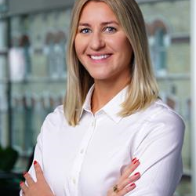
Jenelle Sobey (CEO and Co-Founder, Riddl) Jenelle is a co-founder and CEO at RIDDL, a tool that tracks, manages and measures ESGs, impact investments and quantifies returns. Partner and former Managing Partner of Code + Mortar (norex.ca), an interactive web and invention firm, globally recognized by the Webby’s (the Oscars of the web). Code + Mortar was acquired by Revolve Marketing in 2020. In 2017, Jenelle was recognized as the National Emerging Leader in ICT, and was awarded St Francis Xavier University’s Young Alumna of the Year (2017). Jenelle received Digital Nova Scotia’s Power IT Up Next generation Award (2016), was recognized as one of the Halifax Chamber of Commerce’s Change Agents of the Year (2015). She has been recognized as one of 21 emerging leaders in New Brunswick by 21inc (2013) and one of 20 in Atlantic Canada by 4Front (2014). Jenelle holds a Graduate Diploma in Social Innovation, University of Waterloo (2014), Masters of Arts in Political Science, University of New Brunswick (2011), Bachelor of Arts in Political Science, St Francis Xavier University (2008).
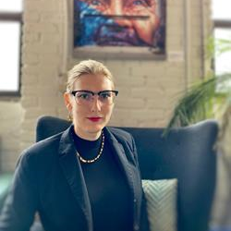
Jade Pichette (Director of Programs, Pride at Work Canada) Jade Pichette (they/them) is an inclusion, diversity, equity, and accessibility (IDEA!) professional based in Tkarón:to/Toronto. Currently, Jade serves as the Director of Programs at Pride at Work Canada, where they work with over 250 large employers across Canada around gender expression, gender identity, and sexual orientation inclusion. Previously, Jade served as the Volunteer and Community Outreach Coordinator at the ArQuives, the Education Programs Coordinator at Kind Space, and an independent inclusion consultant. They were one of the authors of Transitioning Employers: A survey of policies and practices for trans inclusive workplaces and are the cohost of the Uncovering Belonging Podcast. Jade has been named one of Future of Good’s 2022 Young Impact Leaders and Toronto Metropolitan University’s 2021 Pride Champions. In their spare time they can be found geeking out over queer, trans, and Norse histories, disability justice, interfaith advocacy, firekeeping, and spending time with their chosen family.
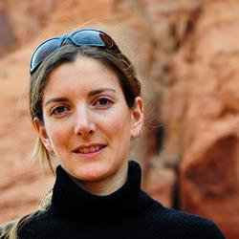
Janet Newbury (Consultant, Inclusion Powell River) Janet Newbury is a consultant, researcher, writer, and instructor and is deeply involved in community. Her research and practice prioritize health and wellness of children, families, and communities through the pursuit of social and structural justice. She lives and works on the traditional territory of the ɬəʔamɛn (Tla’amin) People, who are a self-governing Nation.


Angela Taylor (CEO (Founder), Inspire Community Outreach) Angela is the CEO and Founder of Inspire Community Outreach, a Canadian charity supporting families living with mental health issues and neurological/cognitive differences. She has a Post Baccalaureate in Education, a Masters in Disability studies, and is currently completing her PhD in Education, researching effective therapeutic care for the neurodivergent. Her passion lies in being a community helper, for which she is celebrating 23 years of service, being an ally, and working alongside multiple charities who support complex populations. She is multiply neurodivergent, an author, an artist, and lives in Manitoba, Canada, with her 3 young children.
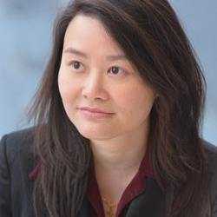
Dr. Anna Victoria Wong (Executive Director, Community Family Services of Ontario) Dr. Anna Victoria Wong is a journalist and doctor in speech-language pathology by training, and health executive and community advocate by profession. Anna spent years in communications in corporate, public, academic, and social service sectors. Anna’s doctoral research focused on access equity to health services for populations with invisible communicative disability. Anna is the Executive Director of Community Family Services of Ontario, which provides East-Asian Ontarians with mental health, settlement, disabilities and special needs services. A is also an Ally in Accessibility, and the Chair of Ontario Chinese Health Coalition. Anna and CFSO are known for serving socio-politically oppressed Hongkongers through IRCC’s Hong Kong Pathway.
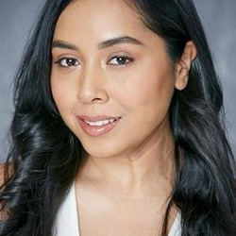
Sinthea Chowdhury is a national project coordinator at Ready, Willing, able. Sinthea has spent the last 10+ years workings with BIPOC autism communities in Ontario, supporting them in building community capacity and in developing culturally relevant autism resources. Sinthea hopes to continue working with the many diverse disability communities throughout Canada and to further develop her intersectional lens.

Dr. Mahadeo Sukhai (Vice-President Research and International Affairs & Chief Accessibility Officer, (CNIB) Canadian National Institute for the Blind) Dr. Mahadeo Sukhai is the world’s first congenitally blind biomedical research scientist. Mahadeo is the Head of Research and Chief Accessibility Officer for the CNIB (Canadian National Institute for the Blind), having previously served as a research scientist at the University Health Network in Toronto. Dr. Sukhai is the Principal Investigator for and co-author of "Creating a Culture of Accessibility in the Sciences," a book based on his groundbreaking work on access to science within higher education, and serves as the principal investigator for national projects to understand the student experience for persons with disabilities, and to examine accessibility and inclusion within science education and healthcare.
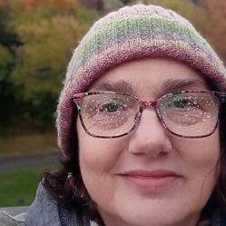
Arlene Phillips (Provincial Human Rights Committee, Ontario Public Service Employees Union) Arlene Phillips is active in the Ontario Public Service Employees Union, currently on the Provincial Human Rights Committee for OPSEU Region Six, Vice President for local 669 and Facilitator for Anti-Black Racism. Former Treasurer for the North Bay and District Labour Council and active on the North Bay Waste Resources Committee. Last but not least, she is the VP of the Workers with Disabilities for the Canadian Labour Congress. Arlene was taken out of Special Education classes in Grade One, as she was functioning well enough to blend in with the regular part of the class. Arlene was officially labeled in Grade nine with learning differences. In grade ten, she was put into a special classes that helped her to identify and correct what was going on in her brain. She graduated Highschool with Honours, graduated from University of Toronto with a Bachelor of Arts, Sociology degree and earned a diploma in Alternate Dispute Resolution from Canadore College. An activist for learning differences (and other things) especially helping navigate her child through the public and post-secondary education systems.
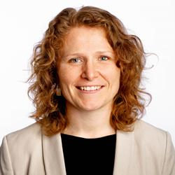
Kim Donaldson (Pathways Lead, Fable) Kim Donaldson is the Pathways Lead at Fable. Kim brings experience from the non-profit sector where she supported people with disabilities in gaining employment. This work led her to becoming an advocate for accessible and inclusive workplaces. Kim has worked with Fable’s Community team to provide flexible and consistent work opportunities at scale to people with disabilities. Now at Fable, Kim leads a team to create free, accessible, and on-demand course content to help people with disabilities advance their careers in the tech sector.

Pamela Lefaive (Manager - Policy, Public Safety Canada Employment and Social Development Canada) Pam Lefaive is the Director for the Youth Employment and Skills Strategy (YESS) at Employment and Social Development Canada. As a key horizontal Strategy, the YESS ensures Canadian youth, particularly those furthest from employment, have access to skills development and work experience needed to be successful in todays labour market. Prior to joining ESDC in 2021, Pam was responsible for implementing Modern Treaties at Crown Indigenous Relations and Northern Affairs. Over the years, she has supported policy development in areas covering social, economic and security issues.
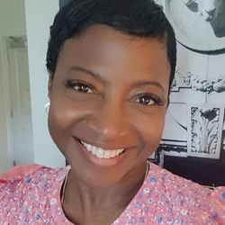
Carolyn Tinglin (Executive Director, (YAIJ) The Youth Alliance for Intersectional Justice) Carolyn Tinglin is one of the team supporters for the Youth Alliance for Intersectional Justice (YAIJ). Carolyn is also a PhD candidate at SFU studying the intersections of student identities, special education and teacher practice and works as a research assistant at SFU's Centre for Education, Law, and Society (CELS).

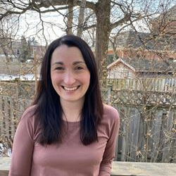
Julia Holmes (Research Coordinator, McMaster University) Julia Holmes is an Occupational Therapist and Research Coordinator for the Inclusive Design for Employment Access (IDEA) Social Innovation Lab in the School of Rehabilitation Science at McMaster University. She is also a Research Assistant with the Social Justice in Mental Health Research Lab at Western University. In her research work, she has been involved in several large research projects related to accessibility, mental illness, poverty, homelessness and the impact of meaningful activity on mental health and wellbeing.
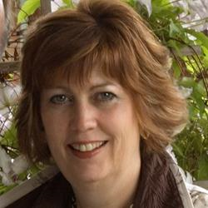
Lorene Bodiam (Community Advocate, Former City of Toronto Now and Independent Community Advocate) As the Toronto Parks, Forestry and Recreation Advocate for People with Disabilities, Lorene designed and provided leadership and expert advice for a full spectrum of Parks, Forestry and Recreation programs and services for people with disabilities. In addition, she was responsible for ensuring The Department complied with the Provincial legislative requirements under the Accessibility for Ontarians with Disabilities Act (AODA). Lorene has been recognized for her work; in producing a comprehensive study entitled "Getting Services Right for Torontonians with Disabilities: Demographics and Service Delivery Expectations"; in creating the first recreational booklet in Toronto which was made fully accessible and was recognized by the Mayor and members of council; and in co-ordinating the first accessibility efforts in Toronto's 2010 Municipal Election. Lorene has worked extensively in partnership with the disability community through the development and co-ordination of a highly involved and respected Parks, Forestry and Recreation Community Disability Steering Committee as well as working actively with over 300 agency contacts. She has a special interest and expertise in social inclusion and community development. Now retired she continues to stay active supporting marginalized groups to find fair and equitable access to City services.
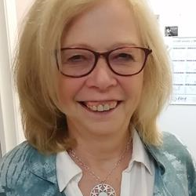
Lilla Tipton (Inclusion Powell River) Lilla Tipton is the recently retired CEO of the inclusion Powell River Society, after 26 years with inclusion. She continues her involvement on the Board of Directors of Powell River Innovation and Social Enterprise Ltd. She was instrumental in the creation of the handyDART system in BC and operated a non-profit transportation service for people with disabilities for 18 years in Prince George, B.C. Her interest and excitement in innovative projects for persons with disabilities continues, particularly employment.
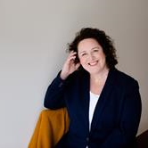
Kristin Bower (Partner, Leda HR) Kristin brings her two decades of Human Resources experience creating equitable and inclusive workplaces to a wide variety of clients as a founding partner in Leda HR, an equity, diversity, and inclusion (EDI) consulting practice. She has led work in the areas of EDI audits and strategy development, disability and inclusive employment programs, mental health awareness and psychologically safe and heathy workplaces, and EDI training such as intercultural competency and unconscious bias. Kristin is a member of the CSA Group Technical Committee on the National Standard for Psychological Health and Safety in the Workplace and CSA Group Technical Subcommittee for Mental Health and Well-being in Community Residential Care Settings, and works as an EDI editor for Pearson reviewing post-secondary level textbooks for inclusive language prior to publishing. She is also the co-author of the provincially and federally funded Untapped Talent: B2B Guide to Innovative Hiring and Retention. Previously recognized with Open Door Group’s UnTapped Award for her mental health advocacy work, she is a frequent speaker at conferences and in workplaces and has collaborated with the Canadian Mental Health Association (CMHA), the Mental Health Commission of Canada and the Conference Board of Canada. Her writing has been published in People Talk and Visions magazines and the intelliHR blog, among other publications, and she has been featured in the Globe and Mail and on CBC Radio and Roundhouse Radio. Kristin holds an Award of Achievement in Diversity & Inclusion from the University of British Columbia studied Human Resources Management at the British Columbia Institute of Technology.
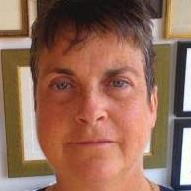
Chloë Atkins (Primary Investigator, Associate Professor (staus-only/statut d'observateur) The PROUD Project, University of Toronto) Chloë Atkins is the primary investigator of the PROUD Project. Dr. Atkins has research interests in disability, bioethics, vulnerable minority identities, human rights, phenomenological research and narrative scholarship. Atkins holds a PhD in Political Science (Political Theory) and a post doctorate from Cornell University Law School in feminist legal jurisprudence. Atkins is the author of My Imaginary Illness (Cornell 2010), awarded 3 prizes including The American Journal of Nursing’s Book of The Year (2011).
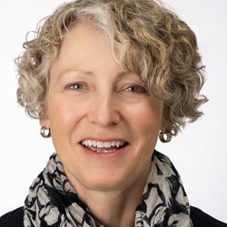
Karen Kelsey (Relationship Manager, Canada, Lime Connect) Karen Kelsey is Lime Connect's Relationship Manager in Canada, where she is responsible for managing and building the corporate and post-secondary educational institution partnerships integral to the success of Lime Connect in the Canadian marketplace. Karen also focuses on attracting high-potential students and alumni to grow The Lime Network in Canada, and she acts as the lead and coordinator for the active Canadian volunteer base - Lime Connect Ambassadors. Ms. Kelsey brings many years of relationship management, human resources management and people management experience in the financial services sector to her role.
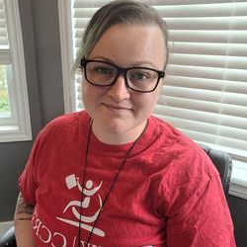
Linda Brown (eLearning and Curriculum Developer, CCRW) Linda is an autistic ADHD self-advocate and eLearning curriculum developer working in disability employment services. When Linda isn't busy designing inclusive and accessible online learning experiences, they are busy with community advocacy, parenting, and enjoying the outdoors. With over 15 years experience in youth mental health initiatives and research, Linda's passion lives in building reciprocal and transformation peer-support relationships with young people to help elevate them to self-actualize their goals.

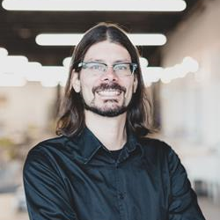
Francis Charrier (Ph.D Student, Cirris) Francis Charrier est candidat au doctorat à l’École de travail social et de criminologie de l’Université Laval. Il s'intéresse tout particulièrement aux expériences de conciliation travail-vie personnelle des travailleur.se.s ayant des incapacités et comment celles-ci favorisent ou non leur maintien en emploi. Francis Charrier travaille actuellement au Centre interdisciplinaire de recherche en réadaptation et intégration sociale (CIRRIS) en tant que professionnel de recherche. Auparavant, il a occupé le poste de coordonnateur du Réseau international sur le Processus de production du handicap (RIPPH) pendant neuf ans.

Dominique Michaud (Postulante au doctorat, Université Laval) Je détiens un baccalauréat en mathématiques-informatique et une formation collégiale technique en métiers d'art textile. J'ai travaillé comme consultante en informatique pendant quelques années avant de revenir aux études. Je mélange les disciplines pour renouveler mon inspiration artistique et trouver de nouvelles façons d’appréhender le savoir. Je m’intéresse au mélange entre l’art et les nouvelles technologies et aux interactions que cela suscite.
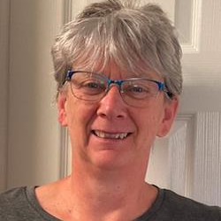
Gail Holdner (Project Coordinator, CUPW Special Needs Project) I coordinate the Special Needs and Moving On projects that support CUPW and UPCE/PSAC postal workers across the country.

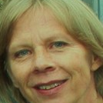
Shellie Bird (CUPW National Child Care Coordinator, Canadian Union of Postal Workers) Shellie Bird works for the Canadian Union of Postal Workers (CUPW) as the National Child Care Coordinator. Shellie’s work involves coordinating research, member needs assessment and to work with community partners to develop projects that support postal workers with their child care needs

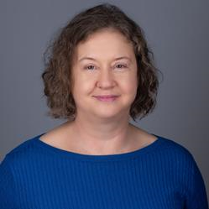
Rosemary Leslie (Senior Administrative Officer, Environment and Climate Change Canada) Rosemary worked for 25 years as a professional engineer, mainly with the federal government. She now works in administration in the federal department of Environment and Climate Change Canada. She enjoys running, cross-country skiing, yoga, reading fiction and non-fiction and meeting with family and friends.


Kathy Beitz (Lead, Knowledge Translation, CNIB) With a background in early childhood education and resource consulting, I have 20 years working along side children and families with adversities. Focussing on social and emotional development and fostering, inclusive environments I had recently made the shift to working in accessibility a year ago, looking to support research efforts to establish equitable, supports and rights for people with disabilities

Dharshi Polio (Director, Human Resources, SAAAC Autism Centre) Dharshi Polio has been in the human resources space for over 25 years. She has a strong record of achievement in a wide range of HR areas including policies and procedures, talent acquisition, employee development, performance management, and training and development. Dharshi has worked with Toronto- based health care providers to build HR capacity and has experience with leading brands such as Le Chateau where she was National Talent Development Acquisition Director. For the past two years, Ms. Polio has focused her expertise in the intellectual and developmental disabilities sector specializing in HR, vocational training, specifically creating a pipeline for the employment of SAAAC clients to external organizations.
Jonathan Proulx Guimond (Étudiant au 2e cycle, Université Laval) Il entreprend actuellement une maitrise de recherche en lien avec les arts et les technologies d'assistances où il se concentre entre autres sur l'expérience utilisateur. Avant celleci, il a terminé un baccalauréat en arts visuels et médiatiques et une formation collégiale technique en animation 3D et synthèse d'images.

Rency Michel (Étudiant au 3e cycle en intelligence artificielle, à l'Université Laval) [No Bio]

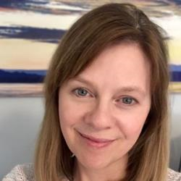
Andrea Whiteley (Postdoctoral Fellow, The PROUD Project, Department of Political Science, University of Toronto) Andrea has her PhD in Communications from the University of Calgary. Her dissertation research focused on open access to research. She has many years expertise in research project management and knowledge mobilization. She is a caregiver of a person with a degenerative neurological illness.
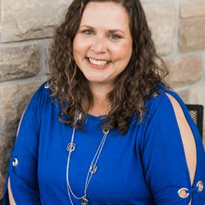
Jolene MacDonald (Founder & Creative Director, Accessibrand Inc.) Jolene is the Founder of Accessibrand™. For over a decade, she has known that people with disabilities needed a different work model to be able to give their full potential to their careers. Accessibrand™ is based on Jolene’s 20+ years of knowledge in the graphic design and marketing industry, as well as her 19 years as a successful entrepreneur. Top that all off with her own disability experience, and out comes an innovative model for a design, marketing and communications agency. Jolene is an advocate, wife and mother of three. She has volunteered with many accessibility/disability related committees and helps other parents advocate.
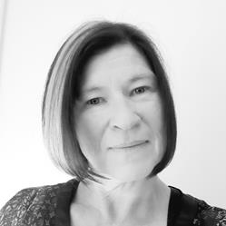
Jennifer Hutcheson (Postal Clerk, CUPW) I am a proud parent of a teen that was diagnosed with autism spectrum disorder at the age of 5. Very involved as a shop steward for our union and its members. I also sit on the Victoria Mail Processing Plant Local Joint Health and Safety Committee as a Delegate.

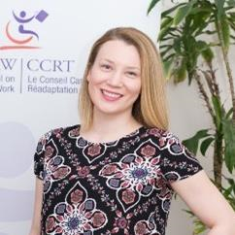
Meghan Kelly (Director, INNoVA) Ensuring that INNoVA truly stretches from coast-to-coast Meghan holds down the fort in the country’s most easterly point. Working out of St. John’s, Newfoundland Meghan has been leading change in the space of Disability and Employment since 2013. Meghan and has been involved on varying levels of project, program and service delivery. Meghan’s most recent area of focus, outside of being a Mom of a 6month old and a 7 year old, has been concentrated in working directly with business and ensuring best in class delivery of customized accessibility consulting services.

Joseph Giulione (Director, CASE; President, Regroupement des organismes spécialisés pour l’emploi des personnes handicapées (ROSEPH), Canadian Association for Supported Employment) Joseph has many years of experience supporting people with disabilities and has worked at L’Arrimage, a supported employment service for people living with mental illness, since 1984. He is the current president for the Regroupement des organismes spécialisés pour l’emploi des personnes handicapées (ROSEPH), and has served on their board of directors since 2006. Joseph consults regularly with government committees, helping to shape policies to facilitate employment integration for people with disabilities. Joseph brings a combination of practical experience, public policy development and insight on the provincial government’s strategies and programs on employment and disability to his position as a CASE board director.
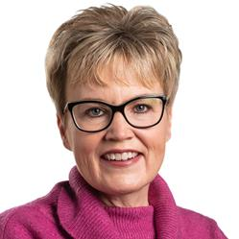
Krista Carr (Executive Vice-President, Inclusion Canada) Krista Carr is a long-time advocate in the inclusion movement. She is the Executive Vice President (CEO) of Inclusion Canada, one of Canada’s 10 largest charitable organizations. Inclusion Canada is a national federation of 300 local and 13 Provincial/Territorial Associations working on behalf of approximately 1 million Canadians with a developmental disability and their families. Krista has over 25 years of experience in the non-profit sector as a champion of inclusion. Before joining Inclusion Canada, she was the Executive Director of the New Brunswick Association for Community Living (NBACL), a leading provincial non-profit organization that works with people with an intellectual disability and their families to accomplish the mission of full inclusion across the lifespan. In her current role, Krista is responsible for leading the Inclusion Canada National organization, the Inclusion Canada Foundation, Inclusive Education Canada (IEC). In addition to her extensive work portfolio, Krista sits on a number of provincial and national disability-related boards and committees. This includes the COVID Disability Advisory Group (CDAG), chaired by the honourable Carla Qualtrough, Minister of Employment and Disability Inclusion. Krista offers a unique perspective on disability-related supports and services, both nationally and internationally. Krista is a graduate of the University of New Brunswick (UNB) where she earned a Bachelor’s in Business Administration (BBA) and several diplomas in Human Resources and Management from UNB’s College of Extended Learning. She is fluently bilingual and works on behalf of CACL’s federation in both French and English. She currently resides in New Brunswick with her husband and two daughters.
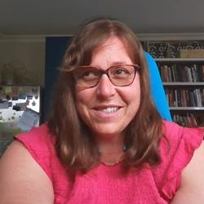
Michaela Knot (Research Consultant, CNIB Research) Michaela has a background in social science research and works in areas of medical anthropology and accessibility research.

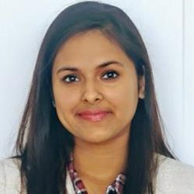
Upasana Panda (Research Assistant, M.Sc Student in Rehabilitation Sciences, McMaster University) Upasana Panda is a MSC student in the Rehabilitation sciences program at McMaster with a background in Psychology and Mental Health. Her interest in pursuing a career in research comes from her values and passion of helping and adding value to the community and people. Her topics of research are in mental health, ethics and disability, allied healthcare worker support and student success. In her free time she enjoys dancing professionally and reading.
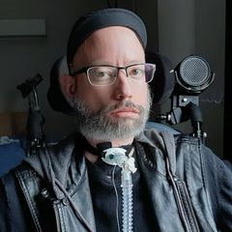
Jonathan Marchand (Chair, Every Canadian Counts) Jonathan is a person with a severe disability, he's an activist and an ardent advocate for the rights of people with disabilities. He's fought long and hard to leave the long-term care facility and live in the community using self-directed personal assistance. He wants to improve the support people with disabilities have to access to so that they become full citizens.

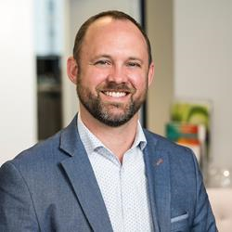
Mark Chapeskie (Vice President of Program Development, Electricity Human Resources Canada) As Vice President of Program Development, Mark leads the project and program delivery teams at Electricity Human Resources Canada. Mark has managed research and programs to transfer skills from regulated occupations into unregulated occupations while minimizing jobseeker retraining. Mark has also worked in the international development field in sub-Saharan Africa where he focused on local economic development initiatives and judicial reform. In his spare time, Mark volunteers with organizations such as the Canadian Academy of Health Sciences, QuickStart Autism and Chairs the Autism Family Advisory Committee at the Children’s Hospital of Eastern Ontario
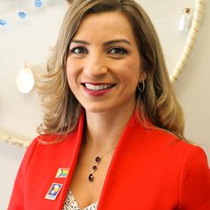
Emmanuelle Lopez (Human Rights, Equity & Diversity Coordinator, UFCW Canada) Emmanuelle works and plays on the territory of the Mississaugas of the Credit First Nation, the traditional territory of the Anishinaabe, Haudenosaunee, Wendat peoples and many other nations whose land was occupied due to settler colonialism. As Human Rights, Equity and Diversity (HRED) Co-ordinator for UFCW Canada, she is proud to serve as Chair of the UFCW Canada HRED Committee, the UFCW Canada Indigenous Sub-Committee and as an Executive Committee member of the Executive board of UFCW OUTreach. With 20+ years of experience in the labour movement, Emmanuelle leads national equity-focused strategic programming and advocacy initiatives and is dedicated to building worker power through an intersectional, feminist, and anti-oppressive approach.
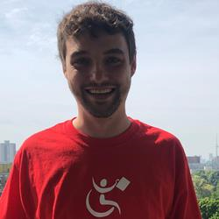
Stephen Irish (Business Services Manager, INNoVA) Based in Toronto, Stephen is passionate about making a difference, and driving change. With over 6 years of experience in Disability and Employment, Stephen leads INNoVA’s Business Services team to achieve and deliver inclusive solutions for all workplaces. Outside of work, Stephen enjoys spending time with his friends and family, or hanging out at the park with his chocolate lab, Leia. Fun fact about Stephen, his favourite ice cream is Mint Chip (Kawartha Dairy to be exact)!

Farshid Sadatsharifi (Operations Project Manager, Accessibrand Inc.) Farshid is an entrepreneur, writer, project manager and unshakable optimist dedicated to ensuring that the communities he belongs to are working towards being more accessible for all. He was born with Cerebral Palsy (CP), which has given him a lifetime living with limited mobility, but - at the same time - a dream and passion for battling the barriers of an inaccessible world. He has joined the Accessibrand™ team to help with communications, content, projects and activities. Farshid is bilingual, speaking both Farsi/Dari and English, with some Arabic and French. He is a newcomer to Canada, having moved to Montreal in 2016 and then more recently to Kitchener-Waterloo. When he’s not busy working, you can find him riding his scooter around the Waterloo region exploring local cafes, podcasting, or enjoying quality time with friends and family!
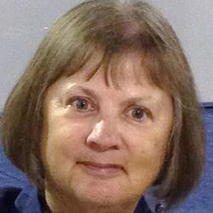
Dr. Margaret Oldfield (Independent Social Scientist and Disability Scholar) Dr. Margaret Oldfield's research focuses on changing workplaces and policy to enable people with chronic illnesses to remain employed. She is on the steering committee of the international organization Reimagining Dementia, a partner on the Canada-wide Disability Confidence in Finance project, a member of the Episodic Disabilities Forum, and a team member on the research project ‘The Impact of Remote Work on Workplace Accessibility for Persons with Disabilities, hosted by McMaster University.’ Her publications and presentations can be viewed at www.researchgate.net/profile/Margaret-Oldfield
Ainsley Latour (Researcher, CNIB) [NO BIO]

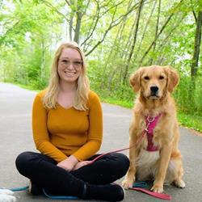
Lexi (Alexandria) Whyte (Certified Trick Dog Instructor, On Cue Animal Training) Lexi graduated from the Michael Shikashio CDBC Aggression in Dogs Master Course. Lexi is a Certified Dog Trainer through The International Positive Dog Training Association (IPDTA-CDT). She is a Certified Trick Dog Instructor (CTDI) through Do More with Your Dog. In addition, Lexi is a supporting member of the Association of Professional Dog Trainers and The International Association of Animal Behaviour Consultants.
AnneMarie Levy (Research Associate, Wilfrid Laurier University) AnneMarie Levy is a neuroscientist, lecturer and researcher at Wilfrid Laurier University. Her research includes Cog@Work, an AGE-WELL program of research investigating employers' responses to workers who develop mild cognitive impairment or dementia (MCI/Dem) while on the job, with the goal of identifying technologies and resources that will better enable employers to create accessible workspaces for employees living with MCI/Dem.
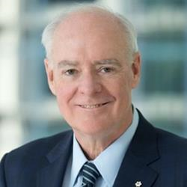
Perrin Beatty (President and CEO, Canadian Chamber of Commerce) The Honourable Perrin Beatty, PC, OC, is the President and Chief Executive Officer of the 200,000- member Canadian Chamber of Commerce, Canada’s largest and most representative national business association. Before joining the Canadian Chamber in August 2007, Perrin held the same role at Canadian Manufacturers & Exporters (CME). A descendant of one of Canada’s most prominent manufacturing families, he grew up in Fergus, Ontario and graduated from the University of Western Ontario in 1971. Perrin was first elected to the House of Commons as a Progressive Conservative in 1972. During his 21 years in Parliament, he served as Minister in seven different portfolios, including Treasury Board, National Revenue, Solicitor General, Defence, National Health and Welfare, Communications and External Affairs. In 1994, Perrin joined a number of private sector boards and worked as a consultant in communications. In addition, he was an Honorary Visiting Professor in Western University’s Department of Political Science. From 1995 to 1999, he served as President and Chief Executive Officer of the Canadian Broadcasting Corporation. In keeping with his long-standing interest in education, Perrin served as Chancellor of the University of Ontario Institute of Technology from 2008 to 2015. He has received honorary Doctor of Law degrees from Western University, the University of Ontario Institute of Technology and Wilfrid Laurier University. Perrin is currently a member of the board of directors of Mitsui Canada and in 2018, he was made an Officer of the Order of Canada for his lifetime of public service and for his devotion to the development of our nation as a community leader and corporate visionary. In 2020, the Government of Japan awarded Perrin the Order of the Rising Sun, Gold and Silver Star, in recognition of his many distinguished achievements in international relations and advancements in Canada-Japan business relations.
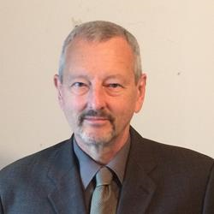
Alec Farquhar (Lead, Engagement, Inclusive Design for Employment Access) Alec Farquhar is a lawyer with a long career in workers’ compensation and occupational health and safety law. He is currently Lead, Engagement, for Inclusive Design for Employment Access – Social Innovation Laboratory and a member of the steering committee for Disability and Work Canada. He is also Coordinator of Asbestos Free Canada. Previously, Alec was Director of the Ontario Ministry of Labour, Immigration, Training and Skills Development (MLITSD) Office of the Worker Adviser (OWA). Alec came to the OWA from the Occupational Health Clinics for Ontario Workers where he was Managing Director, and before that from the MLITSD where he was the Director of the Occupational Health and Safety Branch. Alec has extensive experience in both workers' compensation and occupational health and safety. This includes major involvement with adjudicative tribunals and access to justice. He has a long history of working with vulnerable worker communities including immigrant workers, women and young workers. He has also worked extensively on partnerships with the employer community around dispute resolution, health and safety and employment and retention of workers with disabilities. This includes innovative joint return to work partnerships. Alec is a member of the Executive of the Ontario Bar Association’s Workers’ Compensation Section. He is fluent in Italian and French which has helped him connect directly with the francophone and Italian-Canadian communities. A graduate of Princeton University, Alec has an L.L.B. from the University of Toronto Faculty of Law.

Shruti Goenka (Director Finance, CCRW) I am the Director of Finance at CCRW (Canadian Council on Rehabilitation & Work). Previously I worked for an organization focused on fundraising for charities such as CNIB, Red Cross etc across North America. During the course of my career, I have held a wide variety of roles primarily in the financial services sector & lived in various parts of the world including India, Indonesia, UK, US and now Canada is home. I am very passionate about making a difference through job creation and enhancing employment opportunities for neurodivergent people. This has been the driving force for my transition to the not-for-profit world.
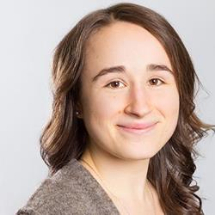
Kiera McDuff (Research Coordinator, University of Toronto) Kiera McDuff is a physiotherapist with clinical experience in critical care. She is also the Research Coordinator for the Episodic Disability and Rehabilitation Research Lab at the University of Toronto where she has been involved in conducting and analyzing interviews on the experiences of disability among people living with Long COVID.

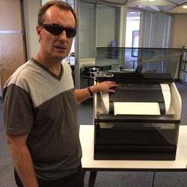
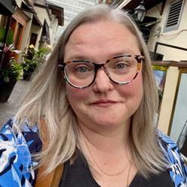
Melissa Egan (National Lead, Episodic Disabilities, Realize) Melissa is the National Lead, Episodic Disabilities at Realize. She has worked in the field of health and HIV for over 15 years as an educator and facilitator, developing and delivering trainings to diverse audiences across Canada. Melissa brings a commitment to inclusion, diversity, equity, and accessibility to her work, and she has worked extensively with 2SLGBTQI+, and Indigenous people. Melissa holds a BA and a BEd from Simon Fraser University in BC and is currently pursuing an MEd at OISE - University of Toronto.
Elvin Dobani (Support Assistant C, City of Toronto: Parks, Forestry and Recreation Division) Elvin joined Toronto Parks, Forestry and Recreation (PFR) in the summer of 2004 to assist with a research study that explored the demographics and recreational service delivery expectations of people with disabilities in Toronto via an extensive consultation process. This research was the first of its kind that he is aware of in Canada, and the recommendations continue to be very relevant in the area of program and service planning. Following the publication of this study with PFR's Office of the Advocate for People with Disabilities in 2010, Elvin continued as a Support Assistant C, where he provides administrative and research support to the disability portfolio of the division's Equity, Diversity and Inclusion section. Elvin assisted in the preparation and delivery of numerous presentations, occasionally tests documents and websites for compatibility with the JAWS screen reader, and makes recommendations for improvement, and maintains an electronic distribution list of over 300 disability service agency contacts. He has been a member of the City's Employee Disability Network since its inception in 2018, and was also most recently a panelist at the City of Toronto's 2018 celebration of the International Day for People with Disabilities. He has an interest in tandem cycling, swimming, and travel.
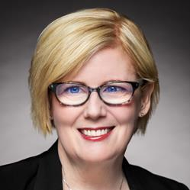
Honourable Carla Qualtrough (Minister of Employment, Workforce Development and Disability Inclusion, Government of Canada) The Honourable Carla Qualtrough was first elected as the Member of Parliament for Delta in 2015. She has served as Minister of Employment, Workforce Development and Disability Inclusion since 2019. Minister Qualtrough has previously served as Minister of Accessibility, Minister of Public Services and Procurement, and Minister of Sport and Persons with Disabilities. A successful lawyer, dedicated volunteer, and Paralympic swimmer, Minister Qualtrough is a strong advocate for Delta, with a commitment to addressing inequality and championing diversity. Committed to equity and inclusion, Minister Qualtrough has practised human rights law at the federal and provincial levels. She chaired the Minister’s Council on Employment and Accessibility in British Columbia, and was an adjudicator with the Workers’ Compensation Appeals Tribunal. Minister Qualtrough has been visually impaired since birth. Passionate about the power of sport and physical activity to change lives, Minister Qualtrough has volunteered locally, nationally, and internationally, including with the International Paralympic Committee and for the Toronto 2015 Pan and Parapan American Games. She has been President of the Canadian Paralympic Committee and Chair of the Sport Dispute Resolution Centre of Canada. She was also on the Board of the Canadian Centre for Ethics in Sport, and was Vice-Chair of the Delta Gymnastics Society. As an athlete, Minister Qualtrough won three Paralympic and four World Championship medals. Minister Qualtrough has degrees in political science from the University of Ottawa and in law from the University of Victoria. Among many awards for her work, she has been named one of Canada’s Most Influential Women in Sport numerous times, and received a Queen Elizabeth II Diamond Jubilee Medal in 2012.
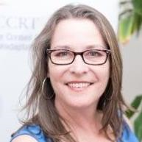
Maureen Haan (President & CEO, (CCRW) Canadian Council on Rehabilitation and Work) Maureen Haan has been the President & CEO of CCRW since 2012. CCRW is the only national organization with the sole vision of equitable and meaningful employment for people with disabilities, in operation for over 40 years. CCRW provides direct services focusing on employment engagement through CCRW best practices and proven results. Maureen has been very active in the cross-disability sector, currently focusing on employment issues. She has been involved with numerous committees and groups that increase awareness of and access for the disability sector and the Deaf community, including involvement with Civil Society on the UN Convention of Rights for Persons with Disabilities (CRPD), and as a Board member on the Accessibility Standards Canada. Maureen was appointed to the COVID-19 Disability Advisory Group (CDAG) during the COVID-19 pandemic and continues to serve in the Minister Disability Advisory Group (MDAG).

Steve Mantis (Chair - Research Action Committee, Ontario Network of Injured Workers Groups) Steve was injured in an industrial accident in 1978 losing his left arm. He went through the Workers Compensation system and saw first-hand how it failed for many injured workers. It became apparent that many workers with a permanent disability became chronically unemployed and lived a life in poverty and depression. He has been active ever since working to improve the lives of injured and disabled workers across Canada. Steve is the Founding member of the Thunder Bay & District Injured Workers Support Group, the Ontario Network of Injured Workers Groups and the Canadian Injured Workers Alliance. He is presently serving as Chair of the Research Action Committee of the Ontario Network of Injured Workers Groups (ONIWG) and sits on the Steering Committee of Disability & Work Canada (DWC).
Lori Cooper (Outreach Specialist, Employment Access Framework) Her top passion is to see equity in employment services & success for Deaf/HoH community. "Everybody benefits when everyone is truly accepted and included." Her life experience as a Deaf Canadian adds authenticity to her presentations for the past 40 years. She's bilingual - American Sign Language and spoken/written English but that will never change the fact she just doesn't hear it, not even a little bit.


Dr. Elisabeth Harrison (Research Associate, ReVision Centre, University of Guelph) Dr. Elisabeth Harrison is Research Associate at Re•Vision: The Centre for Art and Social Justice at the University of Guelph, where she works on the From InVisibility to Inclusion and Bodies in Translation projects. Elisabeth recently completed her PhD in Critical Disability Studies at York University, where her dissertation research focused on the experiences of trans and gender diverse people with mental health care and related social determinants of health.
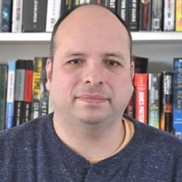
Carlos Sosa (Support Worker, United Food and Commerical Works Local 832) Carlos Sosa is from Winnipeg Manitoba. He is a graduate of the University of Winnipeg and is a Direct Support Professional supporting people with intellectual disabilities that live independently in the community. As a member of the United Food and Commercial Workers he serves as a worker member on his workplace's health and safety committee and recently served as a member of the negotiations committee. As a member of the United Food and Commercial Workers Local 832, Carlos also played an instrumental role in the development of a union based employment program for people with disabilities. He represents the United Food and Commercial Workers on the Canadian Labour Congress's Disability Working Group and is a Director at Large on the board of Inclusion Canada
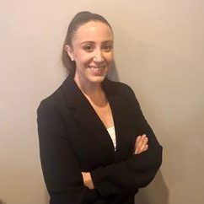
Kristina Fuentes (Postdoctoral Fellow, Bloorview Research Institute, Holland Bloorview Kids Rehabilitation Hospital) Kristina received her PhD in Sociology from the London School of Economics and Political Science. Her research interests lie in workplace and labour market issues, including labour union organizing, gender equality, and workplace disability disclosure and accommodations.

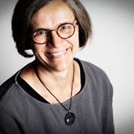
Deborah Stienstra (Jarislowsky Chair in Families and Work, University of Guelph) Deborah Stienstra holds the Jarislowsky Chair in Families and Work at the University of Guelph, where she is the Director of the Live Work Well Research Centre and Professor of Political Science. She is the author of About Canada: Disability Rights (Fernwood, 2020). Her research and publications explore the intersections of disabilities, gender, childhood, and Indigenousness, identifying barriers to, as well as possibilities for, engagement and transformative change. Her work also contributes to comparative and trans/international research and theory related to intersectional disability rights and justice.

Eryka Kaminsky (Training Specialist, Mohawk College) Eryka Kaminsky is a Training Specialist with the Community Access, Engagement and Research team at Mohawk College. Eryka wrote the initial EAF application and has been leading this initiative as Project Manager since it began in October 2021. She has been part of many research and implementation projects at Mohawk College over the last 10-years. Eryka is passionate about equality and believes that diversity in the workplace fosters greater innovation, social connections, and overall morale.
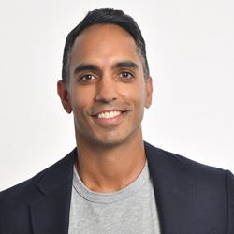
Dr. Arif Jetha (Scientist, Institute for Work & Health) Dr. Arif Jetha is a Scientist at the Institute for Work & Health and an Associate Professor at the University of Toronto’s Dalla Lana School of Public Health. His research aims at understanding how the future of work will impact the health and labour market engagement of vulnerable workers including youth and young adults and people living with chronic disease and disability. He earned his PhD from University of Toronto, and holds an MSc from the London School of Economics and Political Science. Dr. Jetha is the recipient of the Stars Early Career Salary Award from the Arthritis Society, and he currently holds multiple Tri-Council grants as a principal investigator.
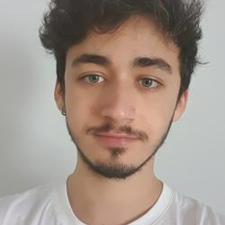
Alexandre Menard (Etudiant, Université Laval) Après une licence de Psychologie en France, j'ai eu une courte expérience de travail dans l'aide à l'insertion professionnelle. Je suis maintenant étudiant en 2ème année de maîtrise en Ergonomie.

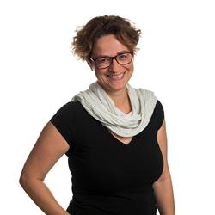
Isabelle Feillou (Professeure adjointe, Université Laval, faculté des sciences sociales, département des relations industrielles) Isabelle Feillou est une praticienne et une professeure en ergonomie à l'Université Laval depuis août 2019. Elle est membre du CIRRIS et de l'équipe PSVI (participation sociale et ville inclusive). Elle s'intéresse au développement d'environnements capacitants au travail permettant de travailler sans se blesser (environnements préventifs), pour une diversité de personnes (environnements inclusifs) et permettant de se développer au travail (environnements développementaux). Elle participe à plusieurs projets sur le handicap, le travail et l'emploi et enseigne en collaboration avec une autre professeure en politiques publiques un cours de second cycle sur cette thématique

Yvonne Yuan (Policy Analyst, Open Policy Ontario) Yvonne Yuan is a public policy analyst and research associate at Open Policy Ontario, a social policy consultancy located in Scarborough. She is committed to policy analysis in small geographies and progressive policy advocacy in general. Over the last year, Yvonne worked extensively on the design of a new Canada Disability Benefit.

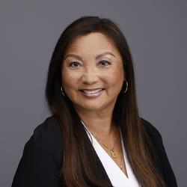
Lily Chang (Secretary-Treasurer, Canadian Labour Congress) Lily Chang was elected Secretary-Treasurer of the Canadian Labour Congress (CLC) at the 29th Constitutional Convention in 2021. Prior to this, Lily worked as Treasurer and elected officer for CUPE Local 79 for almost two decades. She is the first worker of East Asian descent elected to office in Canada’s largest central labour body. As CLC’s Secretary-Treasurer, Lily oversees the organization’s finances. She has also been tasked with guiding the work of the Human Rights Department (including Indigenous and Disability Rights working groups), and representing the CLC at the International Labour Organization.
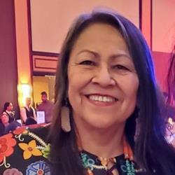
Roberta Oshkawbewisens (Nookamis (Odawa Grandmother Knowledge Keeper)) Little White Buffalo of Bear n Loon Clan Roberta is an Odawa/Ojibawe Nookamis, from Wiikwemikoong Unceded Territory, Manitoulin Island, Ontario. She is a proud mother and grandmother, all round family member. She is Traditional Dancer, Bundle Carrier and Educator. She is presently a National Grandmother with Assembly First Nation and participates as a member with several Boards, Working Committees, Facilitator of Cultural Teachings and Awareness and facilitates as Nookamis of Support, Roberta enjoys and values full heartedly her involvement with First Nation, Metis, Inuit People and the work she does. Miigwech.
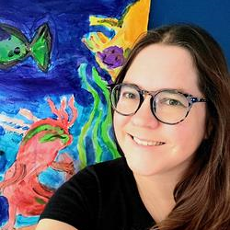
Kathryn Reinders (PhD student, Social Practice and Transformational Change Graduate Research Assistant, Live Work Well Research Centre, University of Guelph, Live Work Well Research Centre) Kathryn is a 2nd year PhD student at the University of Guelph in the social practice and transformational change program where she is interested in public policy, international relations, and human rights. She currently works as a graduate research assistant at the Live Work Well Research Centre on two projects related to the livelihoods and dreams of women, girls, and gender diverse people with Disabilities. Outside of paid-employment she also makes her livelihood through volunteering with her local minor Rugby program, teaching horse riding and martial arts, gardening, and caring her family.
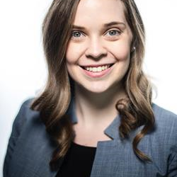
Mary-Kate Fraser (Project Manager, Hospital) Mary-Kate is a Senior Project Manager for a hospital in the Greater Toronto Area. Her work focuses on capital planning for hospital infrastructure projects. At 20 years old she was diagnosed with Retinitis Pigmentosa, an inherited retinal disease that causes progressive vision loss. Mary-Kate has been involved in several initiatives with Fighting Blindness Canada, including its Young Leaders summit and mentorship program, where she had the opportunity to meet and learn from a mentor with a similar career path.
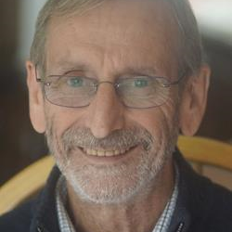
Michael Kendrick (Consultant, Center for Public Representation) I have been a consultant to many hundreds of organizations in many countries on various aspects of leadership and innovation as it relates to persons with disabilities of various kinds. This work has occurred over almost a 50 year period and I have tried to capture it in various publications. See www.kendrickconsulting.org for further information.

Lindsey Simpson (Disability Management Manager, Alberta Health Services) [NO BIO]

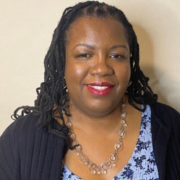
Ingrid Palmer (CEO and Founder, Focus On Ability & Director of Agency, Partnerships and Learning, Up With Women) Ingrid Palmer (she/her) is the CEO and founder of Focus On Ability, an award-winning speaker, author, social justice consultant, the Director of Agency Partnerships and Learning at Up With Women. Her dedication to EDI principles is deeply rooted in her lived/living experiences of early childhood trauma, foster care, and gender based violence. Ingrid has been instrumental to work in the areas of poverty reduction, social justice reform, anti-oppression, and creating opportunities and pathways to success for communities facing adversity. As an advocate, Mrs. Palmer has championed issues in the housing, poverty, education, disability, and child welfare sectors. Her voice and insight have contributed to projects, initiatives, policy, reform, the creation of resources, and the convening of diverse voices. Ingrid's advocacy work includes being the President of the Child Welfare Political Action Committee, a Community Mentor for Black youth with the CHEERS Mentorship program, and member of Black Voices United. Ingrid brings her voice and leadership experience as First Vice Chair of the Council of Canadians with Disabilities.

Dan Samosh (Assistant Professor, Queen's University) Dan studies the workplace inclusion and career success of persons with disabilities. He applies a multi-method approach in his research, using both qualitative and quantitative methods. He is an Assistant Professor of Employment Relations at Queen's University and previously he was a Postdoctoral Research Fellow with the Centre for Industrial Relations and Human Resources at the University of Toronto and the Institute for Work and Health.
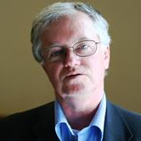
John Stapleton (Principal, Open Policy) John Stapleton is a writer, instructor, benefit designer and a former Innovation Fellow with the Metcalf Foundation. He worked for the Ontario Government for 28 years in the areas of social assistance policy and operations and was Research Director for the Task Force on Modernizing Income Security for Working-Age Adults in Toronto. John teaches public policy for community advocates and is extensively published in local and national media.
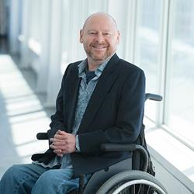
Sylvain Lemay (Conseiller, UQAM) Sylvain Le May a consacré la plus grande partie de sa vie pour défendre les droits des personnes ayant un handicap dans le but d’améliorer leur quotidien au travail et dans les communautés. Il est actuellement co-président du Comité national des personnes ayant un handicap pour le syndicat canadien de la fonction publique (SCFP), il est membre du Comité d’intégration au travail des personnes vivant avec un handicap Congrès des travailleurs du Canada (CTC) ainsi que de la Fédération des travailleurs et travailleuses du Québec (FTQ).
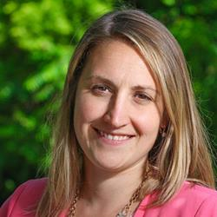
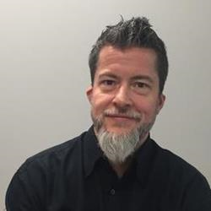
Michael MacDonald (Manager, Health Services, Jazz Aviation) As a person succeeding with a disability, Michael has focused his career on supporting other individuals with disabilities. With a broad background that includes working for insurers, schools, and employers, he currently works with Jazz’s employees as they balance the needs of a safety critical work environment with their own unique health challenges and abilities. As a member of the technical committee, he recently helped shape the new national standard on Work Disability Prevention via the Canadian Standards Association.
Tanya Kett (Career Counsellor, McMaster University) A career professional with 19 years experience, 4 in the non-profit sector and 15 in higher education. Currently a Career Counsellor in the Student Success Centre at McMaster University, working with students and alumni from equity-deserving diversity groups who experience barriers to employment. Instilling confidence, self-advocacy and empowering students to successfully navigate transitions and achieve their professional goals. Credentials include a Master's of Education, Certified Career Development Practitioner and Certified Professional Coach.
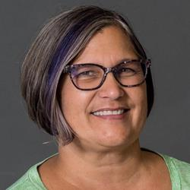
Anne Marie Langlois (Outreach Consultant - EAF Project, Canadian Hard of Hearing Association) Involved in engagement and communication with employers and other stakeholders for the EAF Project Develops marketing materials and employer resources for the project Lead for the Partnership Advisory Committee that is made up of various stakeholders who will guide and advise the project activities Brings her lived experience as a HOH individual to the project
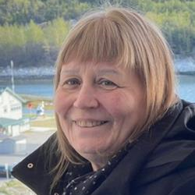
Heather Walkus (National Chair, (CCD) Council of Canadians with Disabilities) Heather Walkus is honoured to be the National Chairperson of the Council of Canadians with Disabilities (CCD) The only National Human Rights Disability Organization run by people and Organizations representing intersectional and cross disability issues for over 46 years. A Community Developer, Organizer, and Social Justice Activist with over 5 decades of experience working in social justice intersecting with identity and cross-disability Human Rights issues both in Canada and Internationally. Heather has over 30 years background in using Universal and Accessible Design, including how accessible design translates into organizational design and personal development in decolonization. Heather uses story telling in trauma informed work and has worked using sports to design disability and culturally appropriate programs and games that are geared to reducing trauma and build self-confidence within children, young adults, and families worldwide. Heather’s two favorite quotes: “Freeing yourself was one thing, claiming ownership of that freed self was another.” - Toni Morrison “If changing the world is not joyful, why bother.” - Heather Walkus
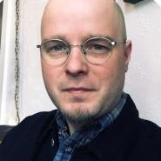
Evan Wicklund (Manitoba Office Lead and Senior Research Officer., Canadian Centre on Disability Studies (o/a Eviance)) Evan D. Wicklund is a Senior Researcher at the Canadian Centre on Disability Studies (o/a Eviance) and a Ph.D. student in the Sociology and Anthropology Department at Carelton University. He is also an Instructor in the Disability and Community Support Program at Red River College. He has a Master's Degree in Cultural Studies (with a specialization in Texts and Cultures) and a Bachelor of Arts (Honors) Degree in Disability Studies from the University of Winnipeg. He has over ten years of experience working in the disability field in a variety of capacities, including academic and community-based research, advocacy, education, employment, and community living.
Michael Trolio (Consultant, Technical Writer, CNIB) [NO BIO]


Lacey Croft (Research Assistant, University of Guelph) Lacey Croft is a PhD candidate in Sociology at York University. Starting from the standpoint of displaced workers, her dissertation research tells the story of workers’ struggles and strategies for dealing with chronic and traumatic stress following a factory closure. Lacey bridges her research on workplace stress with teaching, both as a sessional instructor in Labour Studies and trauma-informed yoga teacher.
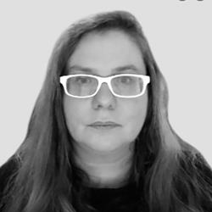
Jocelyne Kiss (Associate professor, Ulaval) Jocelyne Kiss, is an associate professor at Laval University - School of Design, researcher at the Interdisciplinary Center for Research in Rehabilitation and Social Integration (Cirris) CIRRIS, at the International Observatory on the Societal Impacts of AI and Digital Technology (OBVIA ), with the interdisciplinary research community on vulnerability (CRIV). She is currently leading research projects aimed at making the Internet more inclusive, for people with autism, for people with visual difficulties, for the elderly. She is involved in the research for a project "teledevelopment of socio-professional skills for people with disabilities. She teaches AI to train "savvy users". His work focuses on the design of assistance devices integrating virtual environments, creativity and adapted learning systems.
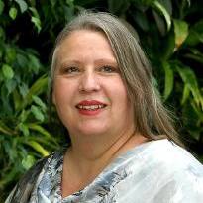
Dr. Lucie Kocum (Associate Professor, Saint Mary's University) Dr. Lucie Kocum is an associate professor at Saint Mary’s University (SMU) in Halifax. Lucie is an applied researcher who integrates lived experience into scholarship, advocacy, and leadership on workplace accessibility. Lucie’s Inclusive by Design Lab is engaged in research and development of a variety of tools designed to improve recruitment, hiring, training, and retention of people with disabilities and other members of equity-seeking groups. Lucie currently serves as a co-chair of the SMU Accessibility Advisory Committee and a member of the Canadian Accessibility Network Advisory Board. La Dre Lucie Kocum est professeure agrégée à Saint Mary’s University (SMU) à Halifax. Lucie est une chercheuse appliquée qui intègre l'expérience vécue dans la recherche, la défense des intérêts et le leadership en matière d'accessibilité en milieu de travail. Son laboratoire, Inclusive by Design Lab, est engagé dans la recherche et le développement d'une variété d'outils conçus pour améliorer le recrutement, l'embauche, la formation et la rétention des personnes handicapées et d'autres membres de groupes en quête d'équité. Lucie est actuellement coprésidente du comité consultatif sur l'accessibilité de SMU et membre du conseil consultatif du Réseau canadien d'accessibilité.

Dr. Emile Tompa (Senior Scientist, Institute for Work & Health, Director, Centre for Research on Work Disability Policy & Director, Inclusive Design for Employment Access) Dr. Emile Tompa is a senior scientist at the Institute for Work & Health. He holds appointments as an Associate Professor in the Department of Economics at McMaster University and as an Assistant Professor at the Dalla Lana School of Public Health at the University of Toronto. He also has an appointment at Pacific Coast University where he is area lead for research and sits on the curriculum and ethics committees. Tompa is Director of the Centre for Research on Work Disability Policy, an eight-year, pan-Canadian initiative funded by a Social Sciences and Humanities Research Council Partnership Grant. Tompa is a labour and health economist with an MBA from the University of British Columbia, an MA in economics from the University of Toronto, and a PhD in economics from McMaster University. Tompa is an associate editor for BMC Public Health, and is on the editorial boards of the Journal of Occupational Rehabilitation and the Scandinavian Journal of Work Environment and Health. He also sits on the National Stakeholder Advisory Panel of the Canadian Labour-Market Information Council. Tompa’s research interests include the consequences of occupational health and safety system design on the health and well-being of individuals and populations, the economic evaluation of workplace interventions for improving the health and well-being of workers, the economic burden of occupational injury and illness, and the analysis of disability policy systems.

Eppo Maertens (Policy Director, (ESDC) Employment and Social Development Canada) Since 2016, Eppo has been working as a policy director where he is responsible for policy managements of new Workforce Development Agreements (WDA) and the Opportunities Fund for Persons with Disabilities. Eppo led the policy development and implementation of the WDAs, including overseeing the Memorandum to Cabinet and Treasury Board Submission and conducting negotiations with provinces and territories.

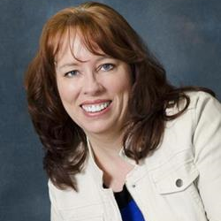
Gail Kesslar (Project Manager, NorQuest College) Gail Kesslar is a Project Manager for the Autism CanTech! project at NorQuest College focused on outreach, collaboration, and connecting with others who want to improve employment outcomes for those with Autism.

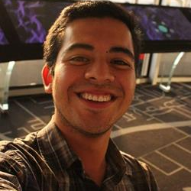
Alejandro Reyes (Membre étudiant du Centre interdisciplinaire de recherche en réadaptation et intégration sociale, Université Laval)
[NO BIO]


Beatrice Bruske (President, Canadian Labour Congress & Secretary-Treasurer, UFCW Local 832) Bea Bruske was elected President of the Canadian Labour Congress at the 29th Constitutional Convention in 2021. She is only the second woman to hold the position. For more than three decades, Bea has served workers and their families as an activist, workers’ advocate, negotiator, community organizer and labour leader. Her experience has served her well as President of CLC in the midst of the COVID-19 pandemic. Before her election as President, Bea served as Vice-President of the UFCW Canada National Council, which sets the strategic direction for the national union and its more than 250,000 members across the country. She had previously served as Secretary-Treasurer for UFCW Local 832, where she was responsible for the largest private-sector union local in Manitoba. Bea’s passion for the rights of working people was ignited in 1987 when she and her UFCW Local 832 co-workers held the line for 125 days to achieve a fair contract at the Westfair grocery chain in Manitoba. Over the next seven years, Bea took on roles as a shop steward, health and safety committee member, and was elected by her fellow members as a vice-president of the Local’s executive board. She is a graduate of the University of Manitoba’s Labour Studies program.
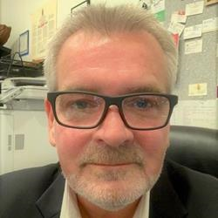
Neil Belanger (Chief Executive Officer, Indigenous Disability Canada) Neil Belanger has over 30 years of experience working within in Canada’s Indigenous and non-Indigenous disability and health sectors. For the past ten years, Neil has been the Executive Director of the British Columbia Aboriginal Network on Disability Society or BCANDS, an Indigenous disability organization holding Special Consultative Status with the United Nations. BCANDS provides a variety of programs and services relating to Indigenous disability across Canada. BCANDS work has been highlighted through numerous provincial, national and international awards and recognition, the most recent being the Zero Project International Award presented to the Society in Vienna, Austria, in 2019. In addition to his work at BCANDS, Neil serves in a variety of disability related advisory roles
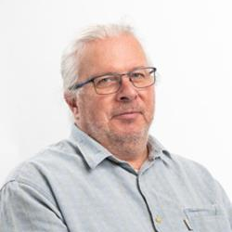
Normand Boucher (Researcher, Cirris-Université laval) Normand Boucher est politologue et sociologue et ses intérêts touchent la problématique de la recherche participative dans l’analyse des transformations des pratiques et des politiques entourant le phénomène du handicap et la citoyenneté. Ses travaux portent sur la problématique du travail et l’emploi ainsi que le développement de politiques publiques à même de soutenir les personnes ayant des incapacités.
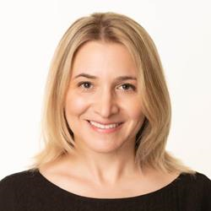
Dr. Rebecca Gewurtz (Associate Professor, McMaster University) Dr. Rebecca Gewurtz is an Associate Professor in the School of Rehabilitation Science and an Adjunct Scientist at the Institute for Work and Health. She holds a Ph.D. from the University of Toronto and completed a collaborative program through the in Health Services and Policy Research. Her research focuses on work disability policy, income insecurity, and employment among people living with disabilities, with a focus on mental illness and other episodic disabilities. She has been examining the experiences of various stakeholders including people with disabilities, service providers, co-workers and employers as people with disabilities are hired and accommodated in diverse workplaces, as well as the impact and coordination of income security benefits.
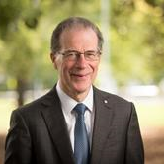
Bruce Bonyhady AM (Professor, Executive Chair and Director, Melbourne Disability Institute, Melbourne Disabioity Institute) Professor Bruce Bonyhady AM is the Executive Chair and Director of the Melbourne Disability Institute at the University of Melbourne. He is one of the key architects of National Disability Insurance Scheme (NDIS) and is widely regarded as the “father” of the Scheme. From 2013 to 2016, he was the Inaugural Chair of the National Disability Insurance Agency. He is also a former President of Philanthropy Australia. Professor Bonyhady is also the father of three adult sons, two of whom have disabilities and in 2010, he became a Member of the Order of Australia for services to people with disability, their families and carers and to the community, as a contributor to a range of charitable organisations.

Yasemin Tuncer (Youth Initiatives Coordinator, DAWN Canada) Yasemin is an immigrant neuroqueer woman dedicated to bringing the experiences of women and gender diverse people to the forefront. She strives to make spaces accessible, safe, inclusive, and free of hierarchy. She has a BA and MA in English literature, yet, wanting to see real changes in communities, she completed a graduate diploma program in Communications at Concordia University. Still feeling the urge to dig deeper into human relations, she started an MA program in Human Systems Intervention at Concordia University in 2022. Yasemin lives with her sassy kid and versatile swiss-army partner surrounded by 40 plants overflowing their pots. Her hobbies are taking snippets of memories, psychoanalyzing everything, and inhaling her little dog.

Brytani McLeod (Inclusion & Accessibility Consultant, Autism CanTech!) Brytani McLeod is the Inclusion & Accessibility Consultant with the ACT! Program, with over 15 years of professional training and experience building, supervising, providing training, and supporting fully inclusive environments. Today she uses that wealth of experience to support employers in creating inclusive workspaces. She is also an individual with lived experience as a neurodivergent person herself.

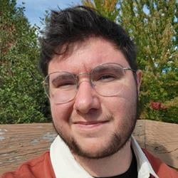
Bei Evely (Student, McMaster University) Bei (he/they) is currently a Social Sciences Master's student at McMaster University and has accessed services provided by Career Access Professional Services (CAPS) when job seeking.

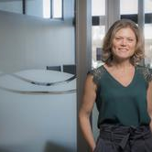
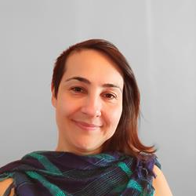
Tanya Houghton (Director Special Care Services, WorkSafeBC) Tanya brings over 20 years’ experience leading and supporting individuals with profound physical and mental health barriers in a variety of public sector settings including government, compensation and not-for profit agencies. With a career that has spanned across 4 countries, Tanya brings an innovative and global perspective to her leadership role. Tanya started her career as a front line social worker in B.C. and the United States before moving into leadership roles in the United Kingdom and Australia providing support, services and governance to individuals affected by severe injury, illness, disease and disability. Tanya is currently the Director of Special Care Services at WorkSafeBC where she provides leadership, vision and direction for claims involving serious injuries, occupational diseases, mental health injuries and workplace fatalities.

Kristina Vyskocil (Career Coach, NorQuest College - Autism CanTech!) Kristina Vyskocil is a Career Coach with Autism CanTech! (ACT!) at NorQuest College, located on Treaty 6 territory. She has over 10 years of combined experience working in education including students of varying abilities, Indigenous students, newcomers and English language learners. Kristina brings five years of coaching experience to her role in ACT!, with expertise in helping post-secondary students develop academic and executive functioning skills. She has a Bachelor of Arts (Honours) from MacEwan University, as well as a Master of Arts and Bachelor of Education from the University of Alberta. Currently, Kristina is completing NAIT's Equity, Diversity and Inclusion Certificate program and is a member of the Centre for Autism's focus group Autistic Gender Minorities Supporting Each Other (AUTGEMS).
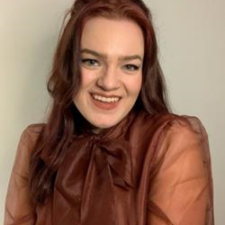
Olivia Boonstra (Senior Research Officer and Knowledge Mobilization Coordinator, Eviance) Olivia Boonstra completed their Masters (MA) in Criminology and Social Justice at Toronto Metropolitan University (TMU) and has worked in community for the past eight years. Olivia has a varied experience having previously worked on projects focused on harm reduction, anti-hate initiatives, prison abolition, and the issue of student debt for students with disabilities. Currently, Eviance is working on a long-term project investigating barriers for students with disabilities accessing post-secondary education and decent work.
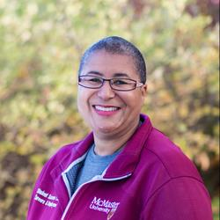
Katherine Hesson-Bolton (Diversity Employment Coordinator, Student Success Centre, McMaster University) Katherine Hesson-Bolton is the inaugural Diversity Employment Coordinator providing foundational consultative support toward the creation of McMaster University’s, Career Access Professional Services (CAPS) supporting equity-deserving students and alumni and those with barriers to employment. Working alongside faculties, community, and employer partners, she assists students, alumni, and employers in guiding their diversity recruitment outreach and related workplace accommodation, inclusion, and funding conversations. Her experiences span 25+ years working in the educational and not-for-profit sectors within front-line and management roles, and having served on accessibility, employment, mental health, community, and educational committees.
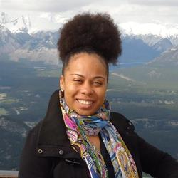
Tammy Yates-Rajaduray (Executive Director, Realize) Tammy C. Yates is the Executive Director of Realize, which hosts the Secretariat of the National Episodic Disabilities Forum. In 2015, she became the first black female Executive Director of a national organization in Canada’s HIV response, as well as among Canada’s national disability organizations. She has worked for over fifteen years in the field of program management. Prior to joining Realize, Tammy was the National Program Manager of the United Nations Population Fund (UNFPA) Trinidad & Tobago Branch Office. She has extensive experience in Gender & Development and Sexual & Reproductive Health, including HIV/AIDS, having worked previously as a Program Officer with the Secretariat of the Caribbean Regional Network of Persons Living With HIV (CRN+) and serving as Chair of the Gender Theme Group of the United Nations System in Trinidad & Tobago. She is a graduate of Wolfson College, Cambridge University, England and the University of the West Indies, St. Augustine, Trinidad.
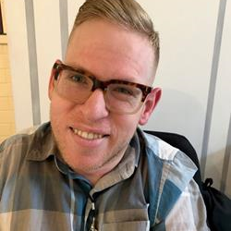
Tim Rose (Senior Consultant, Accessibility, CIBC) Tim Rose is a changemaker and business leader who was fortunate enough to be born with a significant physical disability. Raised to push the envelope, Tim has had the privilege of living, working and studying on three continents which has given him the opportunity to view disability through the lens of many cultures. Tim has been a proud member of CIBC since 2017, holding a variety of roles including compliance, community investment and now client experience where he helps to lead the bank’s Accessibility Centre of Excellence.
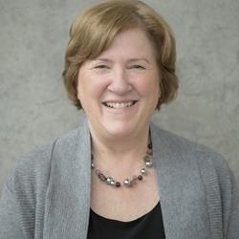
Doramy Ehling (Chief Executive Officer, Rick Hansen Foundation) Doramy Ehling is the Chief Executive Officer of the Rick Hansen Foundation (RHF). As CEO, Doramy leads the Foundation in its’ vision of an inclusive world where people with disabilities are living to their full potential. Over the past 11 years, Ehling has supported the development of several innovations at RHF including the Rick Hansen Institute (a global translational research network) and the Rick Hansen Foundation Accessibility Certification™ program. She has also been involved in national awareness and fundraising campaigns associated with the Foundation’s 20th, 25th and 30th Anniversaries. Prior to joining the Foundation, Doramy worked for 27 years in high performance sport working in Ottawa for several national multi-sport organizations and the Government of Canada/Sport Canada where she worked with the Federal Secretariat on the Vancouver 2010 Olympic and Paralympic Games. During this time she had an opportunity to work on several major policy initiatives including the National Sport Policy, Federal Hosting Policy, Policy on Sport for Athletes with Disabilities, and Policy on Aboriginal Peoples’ Participation in Sport. Doramy has been an active volunteer in the sport community over the past 30 years including serving on the Boards of Volleyball BC, Sport BC and the Sport Medicine Council of Canada and participating in Olympic, Pan American, Commonwealth and World University Games Mission Staffs. She is currently serving as Chair for the Host Committee of the National Women’s Volleyball Training Centre located at the Richmond Olympic Oval. Doramy is a member of the Advisory Board, Diversity Institute, Ryerson University and a member of the Greater Vancouver Board of Trade’s Advisory Committee of the Diversity and Inclusion Leadership Council. Originally from Vancouver and a graduate of the University of British Columbia, Doramy now resides in Richmond, BC with her two daughters.
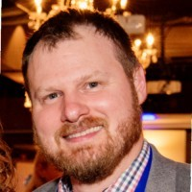
Mike Cyr (National Program Manager, Canadian Council on Rehabilitation and Work) Mike has over 20 years of experience working in the Deaf community and not for profit sector. As an innovative leader, he is always exploring new ideas, strategies, and approaches to improving the quality of life of all members of the community. Mike joined the CCRW team in the Spring of 2022 and is committed to the organization's mission to support meaningful and equitable employment of persons with disabilities. Mike will be your moderator for the Belonging in the Workplace session and hopes to work with the panelists to identify, through disability lenses, what exactly it takes for a workplace to make their employees feel truly belonged.
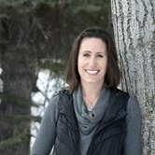
Jessica DeMars (Physiotherapist, Breathe Well Physio) Jessica is a respiratory physiotherapist with a background of working with people with chronic complex illness. She has recognized the impact of Long COVID on the population and has become an ally and advocate and is the Co-Chair of Advocacy for Long COVID Physio. She has developed several courses and webinars on Long COVID to assist with knowledge translation to allied health professionals.
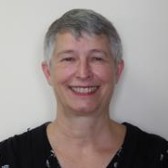
Pascale Chanoux (Coordonnatrice, (CCPH) Comité consultatif personnes handicapées) Titulaire d’un diplôme de troisième cycle universitaire en sciences humaines, Mme Pascale Chanoux est arrivée au Québec en 1993. Elle a assez rapidement commencé à travailler dans les domaines de l’intégration et du maintien en emploi de populations exclues du marché du travail. Elle l’a fait à titre d’intervenante, de formatrice, d’agente de développement, de chercheure ou de coordonnatrice. Elle a exercé de nombreux mandats dans des lieux de concertation ou travaillé sur des projets en partenariat. Et cela fera bientôt quatre ans et demi qu’elle assume la coordination du Comité consultatif Personnes handicapées (CCPH) qui est un forum multi partenarial jouant un rôle aviseur auprès du Gouvernement du Québec sur les politiques publiques d’emploi à l’égard des personnes en situation de handicap. Depuis longtemps, elle a à cœur de contribuer à construire une société québécoise plus inclusive, particulièrement via son marché du travail.
Morgan Ineson (Manager, Education & Research, Fighting Blindness Canada) [NO BIO]

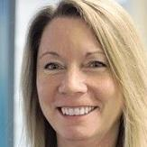
Jamie Millar-Dixon (Principal Consultant, Inclusive Workforce Consultant, MacLeod Silver HR Business Partners, BC Partners in Workforce Innovation) Jamie is the Principal of MacLeod Silver HR Business Partners based in Vancouver, BC and an Inclusive Workforce Consultant with BC Partners in Workforce Innovation. Now in it’s 8th year, BC WiN is a unique recruitment service that helps BC employers connect to the talent pool of people with disabilities/diverse abilities and it’s slated to scale from BC to ON next year. Jamie has an extensive Human Resources background of over 30 years, specializing in workforce diversity and inclusion, recruitment, training and HR start up. Her experience spans multiple industries. She has developed and delivered diversity training programs for both public and private sector employers. Recently, she co-authored Untapped Talent B2B Guide on Innovative Recruitment and Retention, a resource for employers on how to easily adapt each stage in the recruitment, onboarding and retention process to be able to hire more people with disabilities in their business. Jamie is also currently leading the development of recommendations to Accessibility Standards Canada on recruitment and retention standards to support the new Accessible Canada Act for federally regulated employers.
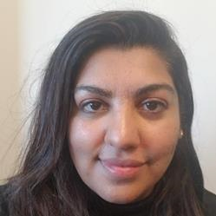
Kay Nasir (Research Coordinator, Institute for Work & Health) Kay Nasir has worked as a project coordinator at the Institute for Work & Health for over 7 years. She holds a BA (honours) in health and society from York University. She is skilled in qualitative research methods and has a keen interest in studying the health effects of income inequality. Kay is supporting Dr. Arif Jetha’s research on the future of work and young people with disabilities.

Paige Maylott (Library Accessibility Services Assistant, McMaster University) Paige Maylott is an accessibility champion who works as an assistant in Library Accessibility Services at McMaster University. She is an active member of several equity-seeking working groups and the chair of UNIFOR 5555’s Pride Committee. In her spare time, Paige moonlights as an accomplished author and awarded the Hamilton Arts & Letters Award for Creative Non-Fiction. Her upcoming book on transition and critical illness in digital spaces, My Body is Distant, is set for release in September 2023 through ECW Press.
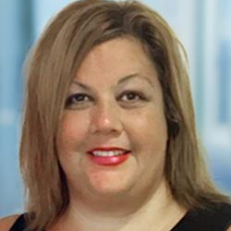
Tammy Morris (Neurodiversity Center of Excellence Leader, EY Canada) Tammy leads the national neurodiversity inclusion effort for EY and stakeholders. Pillars of her work at the firm include overseeing a talented team of consultants delivering emerging technology and business solutions to EY clients, delivering inclusion strategy and accessibility within EY, and leading a consulting service offering for EY Clients expanding their own inclusion efforts. A drive to ‘call in’ conversations and create authentic inclusion and career opportunities for neurodiverse teams fuels her work at EY and the community.
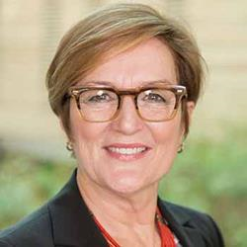
Dr. Josephine McMurray (Associate Professor, Wilfrid Laurier University) Dr. Josephine McMurray, PhD, MBA, MRT, is an Associate Professor at the Lazaridis School of Business & Economics in the Business Technology Management Program, Adjunct Associate Professor in the Arthur Labatt Family School of Nursing at Western University, and Associate Scientific Director at AGE-WELL, Canada’s technology and aging network. Josephine’s research is focussed on issues at the intersection of healthcare, technology & management
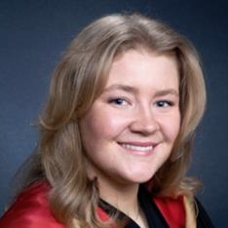
Sophie von Teichman (Research Assistant, McMaster University) Sophie von Teichman is a recent graduate from McMaster University with a Bachelor of Health Sciences Honours. She is currently taking this year to collaborate on research in the field of disability experience, specifically on the experience of persons with disabilities (PwD) during the COVID-19 pandemic and the option of remote work for PwDs. She is passionate about health systems management and policy and is planning on pursuing a Master’s in Public Health next year to further her understanding of these areas and to explore further opportunities in research.

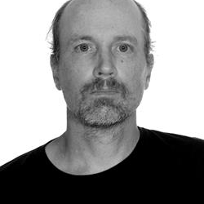
Byron Wood (Member, WESUP - Workers for Ethical Substance Use Policy) Byron Wood (he/him) was terminated by his employer after being diagnosed with a Substance Use Disorder and refusing to participate in a harmful workplace substance use program that put him at risk of overdose death. Byron’s experience inspired him to team up with other workers who have had similar experiences and create the non-profit organization Workers for Ethical Substance Use Policy (WESUP). WESUP fights for systemic change to workplace substance use policy by collaborating with researchers, legal experts, and drug user activist groups. WESUP also provides Peer Navigation Services for workers who are being subjected to harmful workplace substance use policy. Byron lives on the unceded land of the xʷməθkwəy̓əm (Musqueam), Skwxwú7mesh (Squamish), and Səl̓ílwətaʔ/Selilwitulh (Tsleil-Waututh) People.
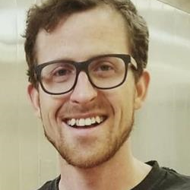
Euan Thomson (EACH+EVERY: Businesses for Harm Reduction) Euan Thomson (he/him) lives in Mohkinstsis / Calgary, Alberta on Treaty 7 land, home of the Tsuut’ina, Stoney Nakoda, Blackfoot Confederacy (Siksika, Kainai, Blackfeet and Piikani) and Metis (Region 3). After noticing the unfortunate stigma and backlash experienced by harm reduction efforts at the hands of a vocal subset of the business community, Euan helped launch EACH+EVERY: Businesses for Harm Reduction in 2020. The coalition allied itself with advocacy groups and organizations representing people who use substances and its membership quickly expanded to encompass a dozen industrial sectors. The organization now stands as a hub of community organizing and solidarity, particularly in Alberta where it counts over 100 of its nearly 200 members. Euan runs an analytical lab serving companies in the craft beverage sector, who are all too familiar with safe supply and supervised consumption sites. https://www.eachandevery.org/ https://twitter.com/_eachandevery https://www.instagram.com/_eachandevery/
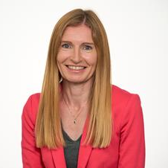
Dr. Sally Lindsay (Senior Scientist, Holland Bloorview Kids Rehabilitation Hospital) Dr. Sally Lindsay is a Senior Scientist at Bloorview Research Institute, Holland Bloorview Kids Rehabilitation Hospital and an Associate Professor in the Departments of Occupational Science and Occupational Therapy, University of Toronto. Her PhD is in the Sociology of Work and Health. Her research focuses on the social inclusion and participation of children and youth with disabilities, especially as they transition to adulthood and into the workplace.

Jocelyn Brown (PhD Student, Saint Mary's University) Jocelyn Brown (she/her) is a inspired researcher beginning her PhD at Saint Mary's University. With a passion and background in industrial-organizational psychology, equity/diversity/inclusion/accessibility, disability management and intercultural communication, she is jumps at opportunities to learn from hand from the lived experience and research existing in this space. Through her work, she is eager to find ways to open the scientific knowledge up to practitioners and the people it impacts most.
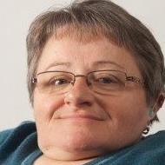
Fran Odette (Board member, Council of Canadians with Disabilities) I am an educator and trainer with a focus on supporting services and communities of disabled people in seeking support through a strength-based and anti-oppressive, anti-ableist lens. I have been doing disability activism and education for over 25+ years with a focus on the intersections of gender, disability and sexuality. I have been a member of the faculty at George Brown College, Toronto in the School of Social and Community Services since 2008.
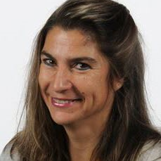
Claude Vincent (Professeure titulaire et chercheure, université laval, Département de réadaptation / Centre interdisciplinaire de recherche en réadaptation et intégration sociale (le Cirris)) Ergothérapeute avec une formation doctorale en santé publique, Claude Vincent s’intéresse à l’utilisation des technologies par les personnes ayant tout type d’incapacités, pour la réalisation de leurs occupations personnelles, sociales et productives. Les nouvelles technologies de l'information et des télécommunications utilisées pour les services de réadaptation et de soutien à domicile lui sont aussi d’un grand intérêt, de même que le développement d'instruments de mesure liés à l'utilisation des technologies, les méthodologies participatives de recherche et la participation sociale.

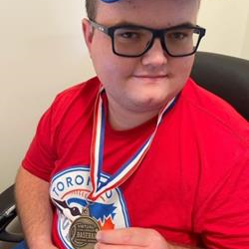
Elliot Smith (Physical Fitness Literacy Associate and Mixed Ability Sport Facilitator, Grandview Kids) Elliot Smith is a skilled athlete, advocate and author. As a 22 year old adult living with Autism Spectrum Disorder (ASD) and Attention Hyperactivity Disorder (ADHD), Elliot is passionate about sharing his lived experiences to increase societal awareness about inclusion and equity. Elliot has recently found meaningful employment as a Physical Fitness Literacy Associate and Mixed Ability Sport Facilitator and actively works to promote strategies that have helped him gain experience and succeed in his employment.
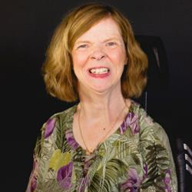
Glenda Watson Hyatt (MASc student, Queen's University) Motivated by her personal experiences and the continual flow of social injustices faced by others living with communication disabilities, Glenda Watson Hyatt is a formidable voice for this systemically overlooked and devalued segment of our society. Through various projects and committees, she aims to increase awareness, understanding and inclusion of people who use alternative means of communication. Currently, Glenda is working on her Master of Applied Science in Mechanical and Materials Engineering at Queen’s University. Her thesis research centers around developing a universal design strategy to promote equity in employing people with communication disabilities. She is also contributing to the project Developing recommendations and guidelines for augmentative and alternative communication to enable persons with motor and communication, and speech impairment to participate in employment, which is funded by Advancing Accessibility Standards Research, Government of Canada.

Rebecca Ipe (Project Coordinator, CanAssist) Rebecca Ipe works as a project coordinator for the Employment Strategy for Youth with Disabilities in BC at CanAssist. She holds two graduate degrees in Education and her research interests lie in inclusion, education, and employment.


Sarah Grindlay (Provincial Employment Strategy Content Writer, CanAssist) As the Provincial Employment Strategy Content Writer, Sarah is responsible for designing, creating, and editing all communications for the Employment Strategy for Youth with Disabilities (ESYDBC) project. Sarah brings over ten years of experience as a writer, editor, manager, and team-builder. She is a UVic alumna (‘15), a person with invisible disability, and proud member of the LGBTQ2S+ community. Sarah holds a Bachelor of Arts (BA) with distinction, specializing in English, Writing and Professional Writing. She is currently completing her certificates in both Editing and Plain Language Writing through Simon Fraser University. In her spare time, Sarah is a dog mom, an amateur potter, a writer of fiction and poetry, and an unsuccessful but enthusiastic gardener.
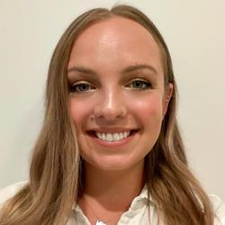
Emily Flegel (Project Coordinator, CanAssist - The Employment Strategy for Youth with Disabilities) One of my greatest passions is advocating for mental health and wellbeing. I recently graduated from the University of Victoria with a Bachelor of Science majoring in Psychology and specializing in mental health and wellbeing. Some of the ways I support my own wellbeing include getting outside with my dog, doing something creative, or finding meaning and community connection through my work or volunteer positions. As a person with disabilities, I am proud to be furthering accessibility for the community through the work I am doing with CanAssist on the Provincial Employment Strategy for Youth with Disabilities.
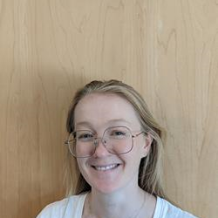
Sarah Molder (Provincial Employment Strategy Project Lead, CanAssist at the University of Victoria) As the Provincial Employment Strategy Project Lead, Sarah monitors and manages the progress of the project. She has her bachelor’s degree in Kinesiology, a Certificate in Non-Profit Management, and four years of program design and development experience.

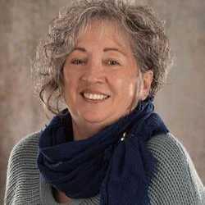
Linda Noel Smith (Liaison Officer, Self-employment benefit program for people with disability, New Brunswick Association of CBDCs) I have always acted as a defender of the person, both in my personal and professional life. Since September 2021, I have been privileged to act as a provincial liaison officer for the SEB PWD program. I feel like a fish in water in this role and I am committed to put my clients in touch with the appropriate services that will facilitate their entrepreneurial experience.
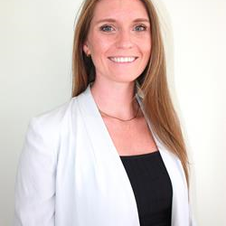
Nicolette Gowan (President and CEO, Gowan Consulting) Nicolette is the President and CEO of Gowan Consulting, a national health and disability organization in Canada, composed of registered Occupational Therapists that focus on work, health and enabling function. She is a registered Occupational Therapist in Ontario with passion for mental health and work function. She has presented internationally on topics spanning from accommodations, ergonomics, return to work and mental health.
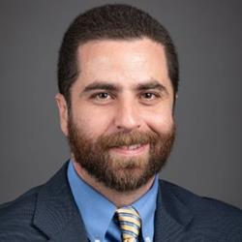
Josh Kirshenblat (Lawyer, Fink & Bornstein P.C.) Josh Kirshenblat graduated from the University of Victoria in 2011. After law school he returned to his hometown of Toronto. He worked in a number of industries after law school, including being part-owner of a small independent bike messenger co-op. It was there that he developed his passion for helping injured workers. In 2019 he enrolled in the Ryerson Law Practice Program. He started working with Fink and Bornstein P.C. in March 2020, and was called to the Bar in August 2020.
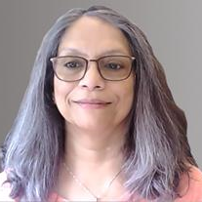
Rohini Peris (President & CEO, Association pour la santé environnementale du Québec - Environmental Health Association of Québec) Experiencing Multiple Chemical Sensitivities (MCS), a disability, since 1996, she has volunteered, managed, and grown ASEQ-EHAQ to around 2000 members, built bridges with groups in Canada and around the world, doctors, scientists, universities, and government to draw attention to this disability and advocate for help and support for this population. She has developed programs, websites, workshops, and webinars for all aspects of the disability for management of the health condition, including workplace accommodation for the disability.

Denise Coward (Project Lead, ReThink Ability) Denise Coward has spent the last 25 years in the non-profit sector, holding various leadership roles at community-based organizations in New Brunswick and Ontario. During her 11 years at CNIB (Vision Loss Rehabilitation) New Brunswick, she was committed to improving and expanding employment services for persons with vision loss across the country. For the past two years, Denise was part of working group re-designing employment services for persons with a disability in New Brunswick and in August 2021, she left her role as Executive Director, Vision Loss Rehabilitation NB to work on Employer Services and ReThink Ability full-time.
Mary Beth MacLean (PhD Candidate, Queen's University) [No bio]

